**Assessment of Marginal Workers in Tamil Nadu**

|  |  |
| --- | --- |
| **Domain Name** | **Applied Data Science** |
| **Project Name** | **Assessment of Marginal Workers in**  **Tamil Nadu-A Socioeconomic Analysis(ADS)** |
| **Date** | **31-10-2023** |
| **Team ID** | **3896** |
| **Team Members Name** | **ARAVIND D**  **ARUNPRABHU U S HARRINVIKNESH S**  **KAVYA M**  **MANVITHA G** |

**Table of Content**

|  |  |
| --- | --- |
| 1 | Introduction |
| 2 | Problem Statement |
| 3 | Introduction |
| 4 | Objectives of the Project |
| 5 | Analysis Approach |
| 6 | Visualization Analysis |
| 7 | Code implementation |
| 8 | Overall Analysis |
| 9 | Conclusion |

**Problem statement :**

“Assessment of Marginal workers in Tamil Nadu”, A Socioeconomic Analysis: Analyse the demographic characteristic of Marginal workers based on age, industry category, and sex, Create visualization such as bar chart, pie chart, or heatmaps to represent the distribution across different categories.

**Introduction:**

This project, "Assessment of Marginal Workers in Tamil Nadu," serves as a comprehensive socioeconomic analysis aimed at examining the demographic characteristics of marginal workers in the state of Tamil Nadu, India. Marginal workers, defined as those employed for less than six months in a year, often face unique socioeconomic challenges. Understanding their demographic attributes, including age, industry category, and gender, is critical for policymakers, researchers, and organizations seeking to develop targeted interventions and policies to improve the well-being of this vulnerable population.

In pursuit of these objectives, this documentation outlines the methodology, data sources, data analysis techniques, and visualizations employed to gain insights into the demographic characteristics of marginal workers in Tamil Nadu.

Through the presentation of bar charts, pie charts, heatmaps, and other visual representations, we offer a comprehensive overview of the distribution of marginal workers across various categories. These insights aim to inform evidence-based decision-making, policy formulation, and interventions that can enhance the socioeconomic conditions and opportunities for marginal workers in the region.

**Objectives of the project:**

The objectives of the project, "Assessment of Marginal Workers in Tamil Nadu,"

1. **Demographic Analysis:** To examine and understand the demographic characteristics of marginal workers in Tamil Nadu, with a focus on age, industry category, and gender.
2. **Age Distribution:** To analyse the age distribution of marginal workers, providing insights into the age groups most affected by seasonal or temporary employment.
3. **Industry Category:** To categorize marginal workers based on the industry or economic sector in which they are employed, offering a breakdown of their occupational diversity.
4. **Gender Disparities:** To investigate and reveal any gender disparities within the population of marginal workers, contributing to a more nuanced understanding of their socioeconomic challenges.
5. **Visualization:** To create visualizations such as bar charts, pie charts, and heatmaps to represent the distribution of marginal workers across different demographic and industry categories, making the data more accessible and actionable for stakeholders and policymakers.
6. **Informed Decision-Making:** To provide policymakers, researchers, and organizations with data-driven insights that can inform evidence-based decision-making, targeted interventions, and the formulation of policies aimed at improving the well-being and opportunities for marginal workers in Tamil Nadu.

By achieving these objectives, the project aims to contribute valuable information for addressing the unique socioeconomic needs of marginal workers and enhancing their quality of life in the region.

**Analysis Approach:**

* 1. **Age Distribution Analysis:**
     + - Create a histogram or bar chart to visualize the age distribution of marginal workers.
       - Calculate relevant statistics, such as mean, median, and standard deviation, to better understand the central tendency and variability of age among marginal workers.
  2. **Industry Category Categorization:**
     + - Group marginal workers based on industry categories, such as agriculture, manufacturing, construction, services, etc.
       - Calculate the percentage distribution of workers in each category.

* 1. **Gender Disparities Analysis:**
     + - Analyse the gender distribution among marginal workers and calculate the proportion of male and female workers.
       - Visualize the gender distribution using charts like pie charts or bar charts.

**Visualization Analysis:**

To analyse the demographic characteristics of marginal workers in Tamil Nadu, several visualization types can be employed to effectively represent the distribution of these workers across different categories. Here are some visualization types that can be used in the analysis:

**1. Bar Charts:**

• Bar charts can represent the distribution of marginal workers in different categories such as age groups, industry categories, and gender. They provide a clear visual comparison of the number or proportion of workers in each category.

**2. Pie Charts:**

• Pie charts are useful for showing the proportion or percentage of marginal workers in various industry categories, age groups, or gender. They provide a quick overview of the distribution.

**3. Heatmaps:**

• Heatmaps can be used to display the concentration or density of marginal workers across different regions or districts in Tamil Nadu. They provide a

geographic view of where these workers are most prevalent.

* 1. **Scatterplots:**

• Scatterplots are valuable for examining correlations between variables, such as age and educational qualifications, or age and income. They can help identify patterns or trends within the data.

**Code Implementation:**

[17]: 1 dataset.info()

<class 'pandas.core.frame.DataFrame'>

RangeIndex: 1386 entries, 0 to 1385 Data columns (total 69 columns):

# Column Non-Null Count Dtype

--- ------ -------------- -----

* + 1. Table Code 1386 non-null object
    2. State Code 1386 non-null int64

In

[18]:

Out[18]:

<

AxesSubplot: xlabel='Age group', ylabel='count'

>

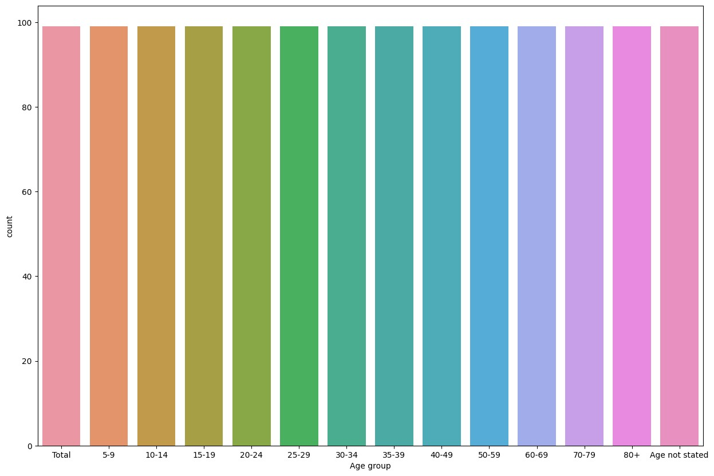

plt

.

figure

(

figsize

**=**

(

15

,

10

))

sns

.

countplot

(

x

**=**

'Age group'

,

data

**=**

dataset

)

1

2

* + 1. District Code 1386 non-null object
    2. Area Name 1386 non-null object
    3. Total/ Rural/ Urban 1386 non-null object
    4. Age group

1386 non-null object

* + 1. W k d f 3 th b t l th 6 th P

# Data Visualization

In [19]:

plt

.

figure

(

figsize

**=**

(

10

,

10

))

sns

.

jointplot

(

dataset

,

x

**=**

'Age group'

,

y

**=**

'Area Name'

)

plt

.

xticks

(

rotation

**=**

90

)

1

2

3

Out[19]: ([0, 1, 2, 3, 4, 5, 6, 7, 8, 9, 10, 11, 12, 13],

[Text(0, 0, 'Total'), Text(1, 0, '5-9'),

Text(2, 0, '10-14'),

Text(3, 0, '15-19'),

Text(4, 0, '20-24'),

Text(5, 0, '25-29'),

Text(6, 0, '30-34'),

Text(7, 0, '35-39'),

Text(8, 0, '40-49'),

Text(9, 0, '50-59'),

Text(10, 0, '60-69'),

Text(11, 0, '70-79'),

Text(12, 0, '80+'),

Text(13, 0, 'Age not stated')])

<Figure size 1000x1000 with 0 Axes>

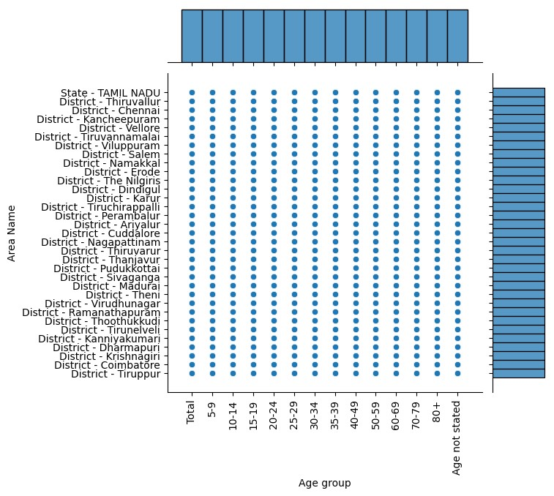

[20]:

Out[20]:

Text(0, 0.5, 'Count')

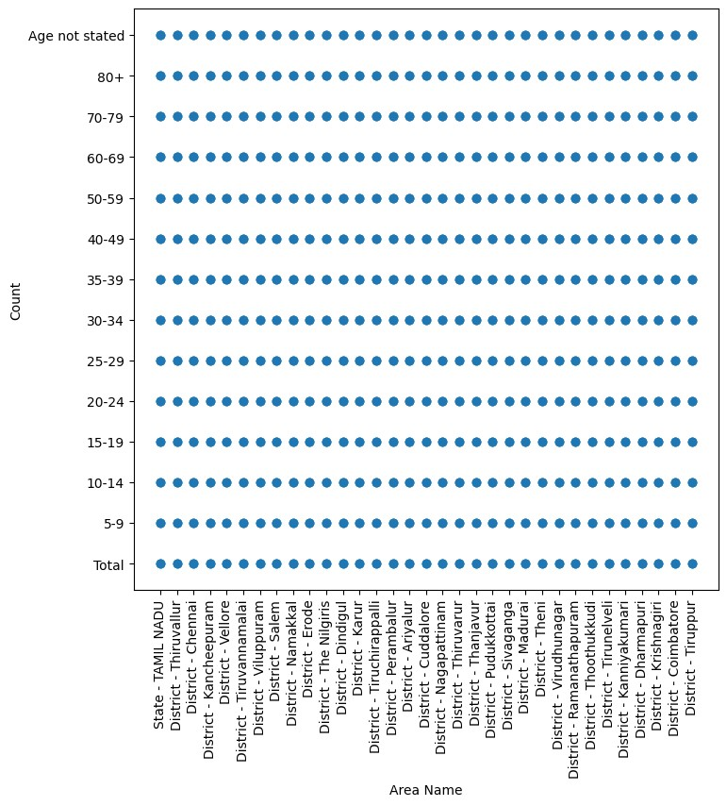

plt

.

figure

(

figsize

**=**

(

8

,

8

))

plt

.

scatter

(

dataset

[

'Area Name'

]

,

dataset

[

'Age group'

])

plt

.

xticks

(

rotation

**=**

90

)

plt

.

xlabel

(

"Area Name"

)

plt

.

ylabel

(

"Count"

)

1

2

3

4

5

6

# Analysis by Age group and Industrial category by persons

In [21]: 1 IndustryCategorybyPerson **=** dataset[['Industrial Category - A - Cultiva 2 'Industrial Category - A - Agricultu

1. 'Industrial Category - A - Plantatio
2. 'Industrial Category - B - Persons',
3. 'Industrial Category - C - HHI - Per
4. 'Industrial Category - C - Non HHI -
5. 'Industrial Category - D & E - Perso
6. 'Industrial Category - F - Persons',
7. 'Industrial Category - G - HHI - Per
8. 'Industrial Category - G - Non HHI -
9. 'Industrial Category - H - Persons',
10. 'Industrial Category - I - Persons',
11. 'Industrial Category - J - HHI - Per
12. 'Industrial Category - J - Non HHI -
13. 'Industrial Category - K to M - Pers
14. 'Industrial Category - N to O - Pers
15. 'Industrial Category - P to Q - Pers
16. 'Industrial Category - R to U - HHI
17. 'Industrial Category - R to U - Non

In [22]: 1 IndustryCategorybyPerson.head()

Out[22]:

**Industrial**

**Category A -**

**Industrial**

**Industrial Plantation, Industrial Industrial**

**Category - Industrial Industrial Industrial**

**Category - Livestock, Category Category**

**A - Category Category Category**

**A - Forestry, - C - HHI - C - Non**

**Agricultural - B - - D & E - - F -**

**Cultivators Fishing, - HHI labourers - Persons Persons Persons**

**- Persons Hunting Persons Persons**

**Persons and allied activities -**

**Persons**

1. 393082 2372446 125099 14979 154133 306528 7137 390275
2. 3363 4169 198 6 228 246 6 264
3. 5072 13939 834 70 996 2808 24 1522
4. 17864 102106 4613 689 6642 28826 319 18661
5. 33647 216966 9171 1490 14366 50791 1032 41762

plt.figure(figsize**=**(100,60)) sns.barplot(IndustryCategorybyPerson)

Out[23]: <AxesSubplot: >

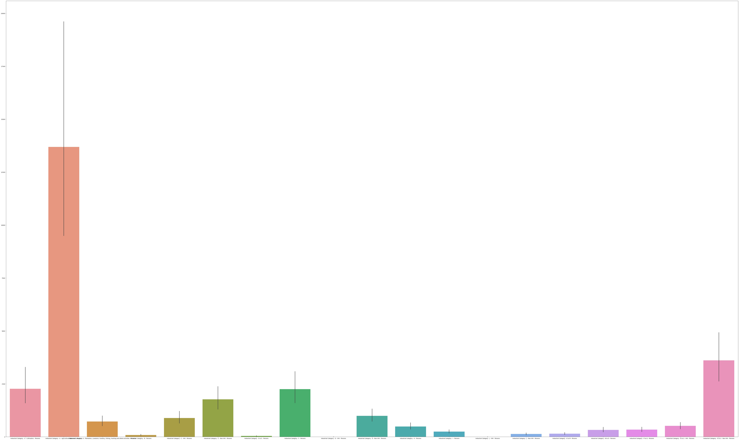

In

Out[24]:

<

seaborn.axisgrid.PairGrid at

0x1a99131d250>

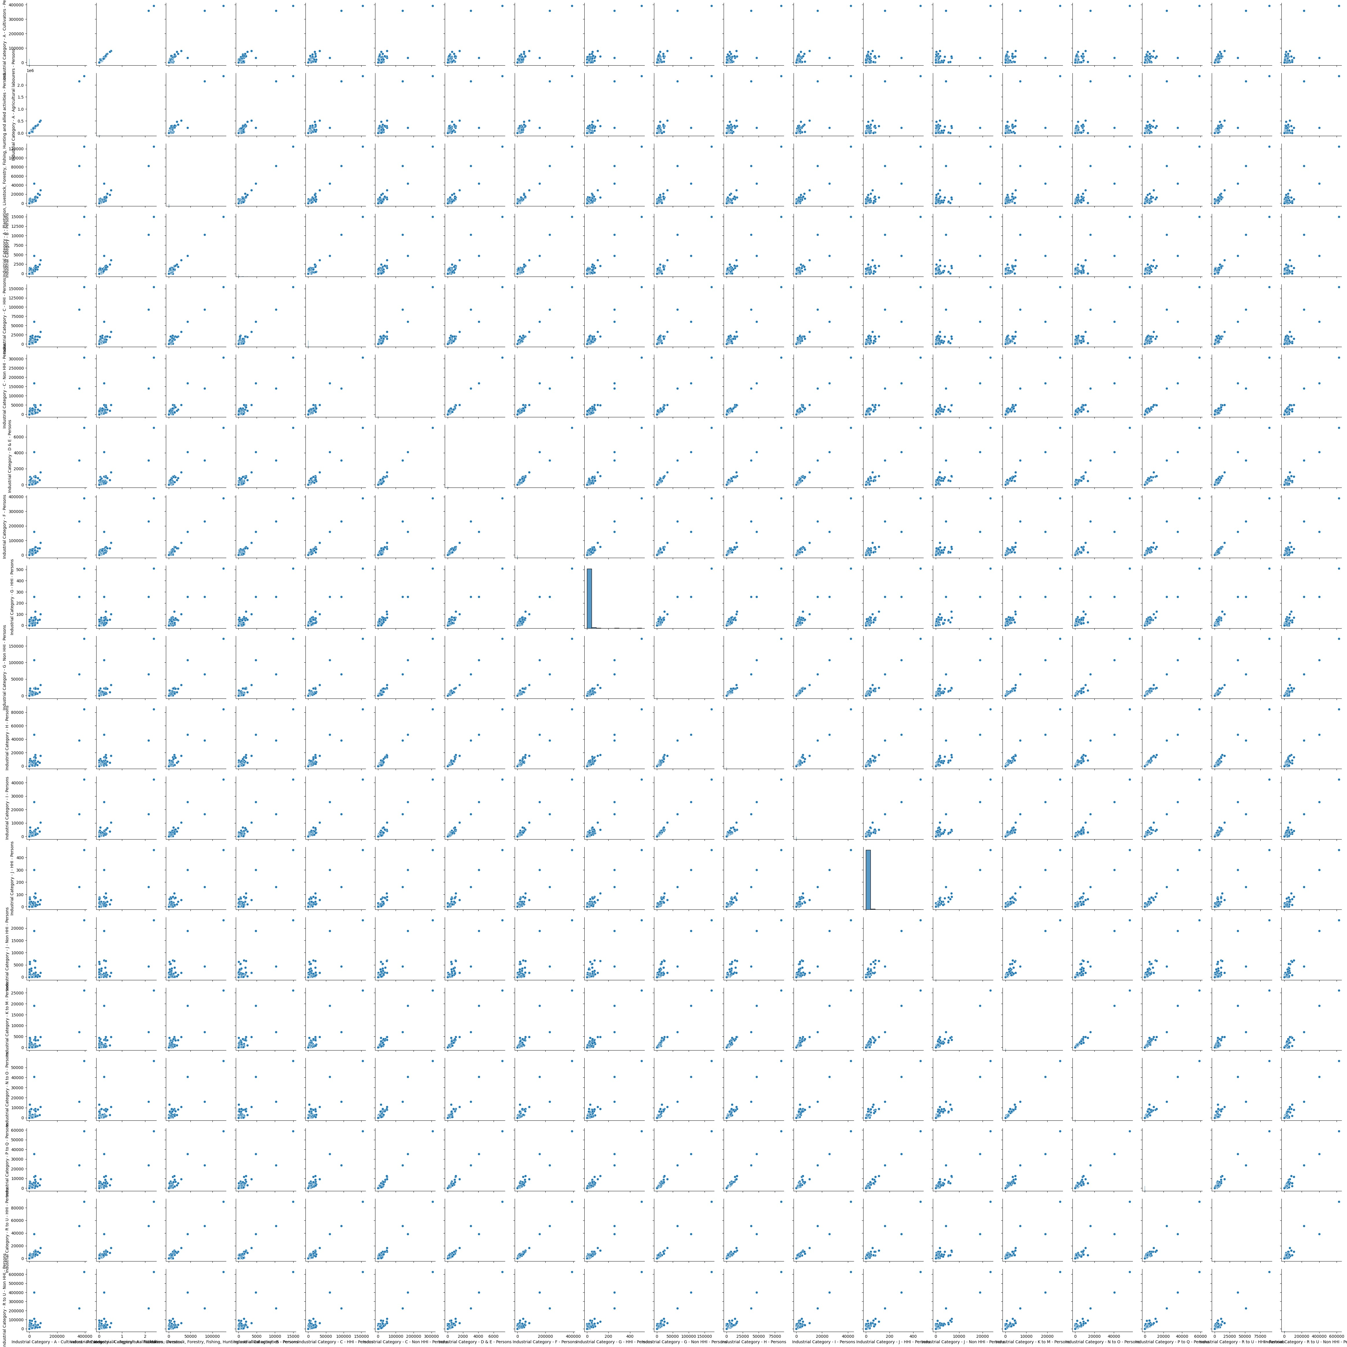

sns

.

pairplot

(

IndustryCategorybyPerson

)

1

plt.figure(figsize**=**(30,25)) sns.heatmap(IndustryCategorybyPerson.corr(),annot**=True**)

Out[25]: <AxesSubplot: >

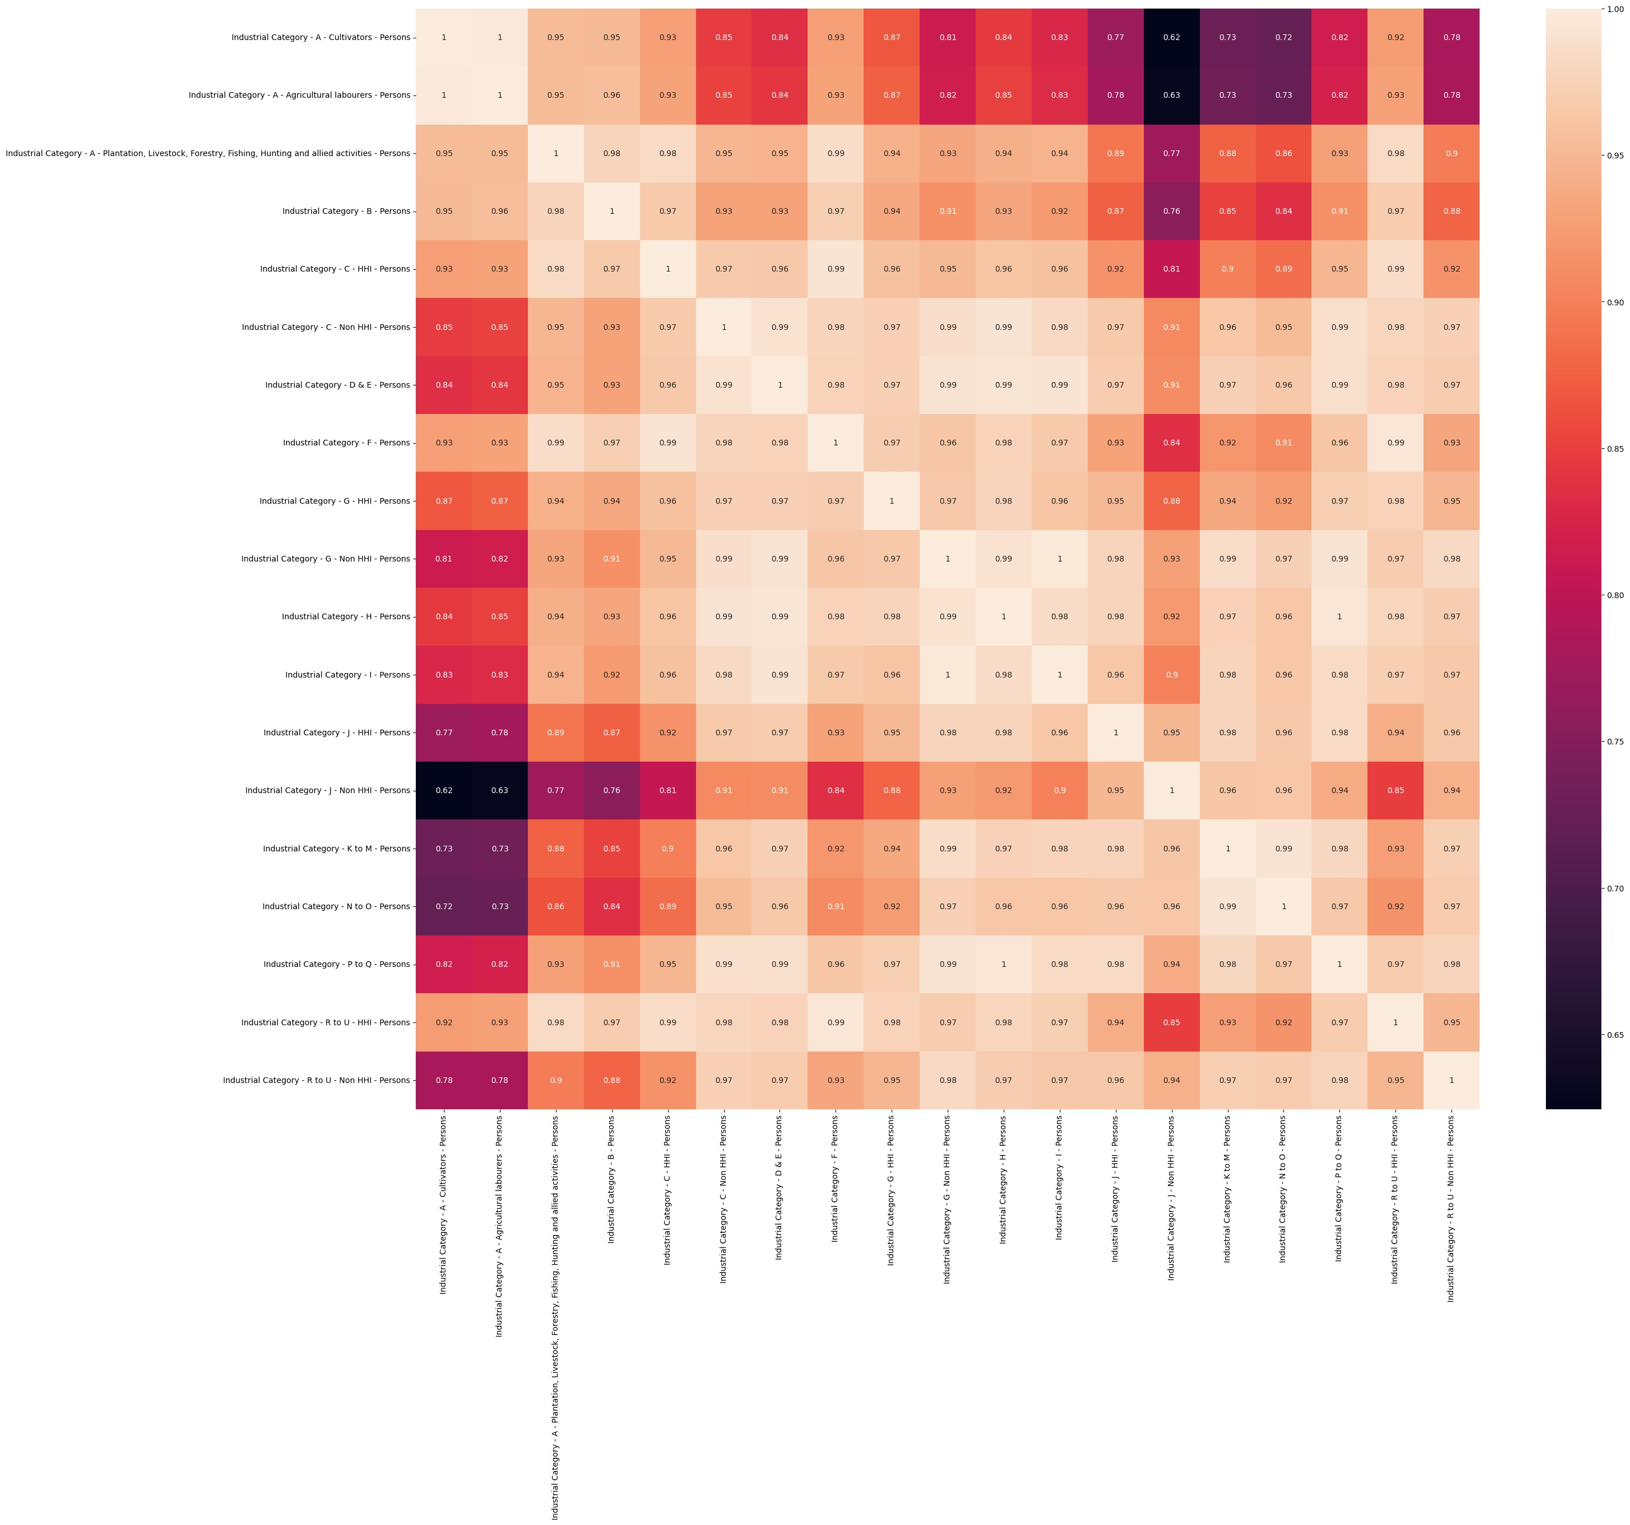

# Analysis by Age group and Industrial category by Males

In [26]: 1 IndustryCategorybyMale **=** dataset[['Industrial Category - A - Cultivato 2 'Industrial Category - A - Agricultu

3 'Industrial Category - A - Plantatio 4 'Industrial Category - B - Males',

1. 'Industrial Category - C - HHI - Mal
2. 'Industrial Category - C - Non HHI -
3. 'Industrial Category - D & E - Males 8 'Industrial Category - F - Males',
4. 'Industrial Category - G - HHI - Mal
5. 'Industrial Category - G - Non HHI -
6. 'Industrial Category - H - Males',
7. 'Industrial Category - I - Males',
8. 'Industrial Category - J - HHI - Mal
9. 'Industrial Category - J - Non HHI -
10. 'Industrial Category - K to M - Male
11. 'Industrial Category - N to O - Male
12. 'Industrial Category - P to Q - Male
13. 'Industrial Category - R to U - HHI
14. 'Industrial Category - R to U - Non

In [27]: 1 IndustryCategorybyMale.head()

Out[27]:

**Industrial**

**Category A -**

**Industrial**

**Industrial Plantation, Industrial**

**Category - Industrial Industrial Industrial Industrial**

**Category - Livestock, Category**

**A - Category Category Category Category**

**A - Forestry, - C - Non**

**Agricultural - B - - C - HHI - D & E - - F -**

**Cultivators Fishing, HHI -**

**labourers - Males - Males Males Males**

**- Males Hunting Males**

**Males and allied activities -**

**Males**

1. 220314 1034184 78052 10290 53418 188464 6003 241619
2. 1592 1992 106 0 113 127 4 176
3. 2486 6974 464 39 394 1416 14 1081
4. 9336 51763 3157 544 2027 14958 285 15695
5. 16930 98959 6302 1092 4374 32445 931 32398

plt.figure(figsize**=**(100,60)) sns.barplot(IndustryCategorybyMale)

Out[28]: <AxesSubplot: >

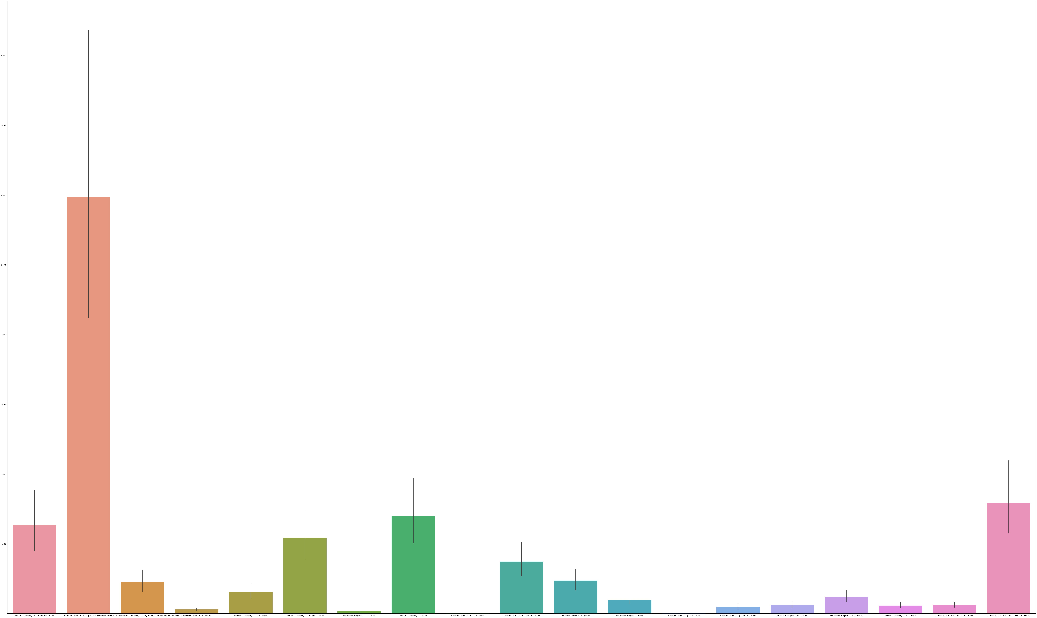

In

Out[29]:

<

seaborn.axisgrid.PairGrid at 0x1a9c5bba

950>

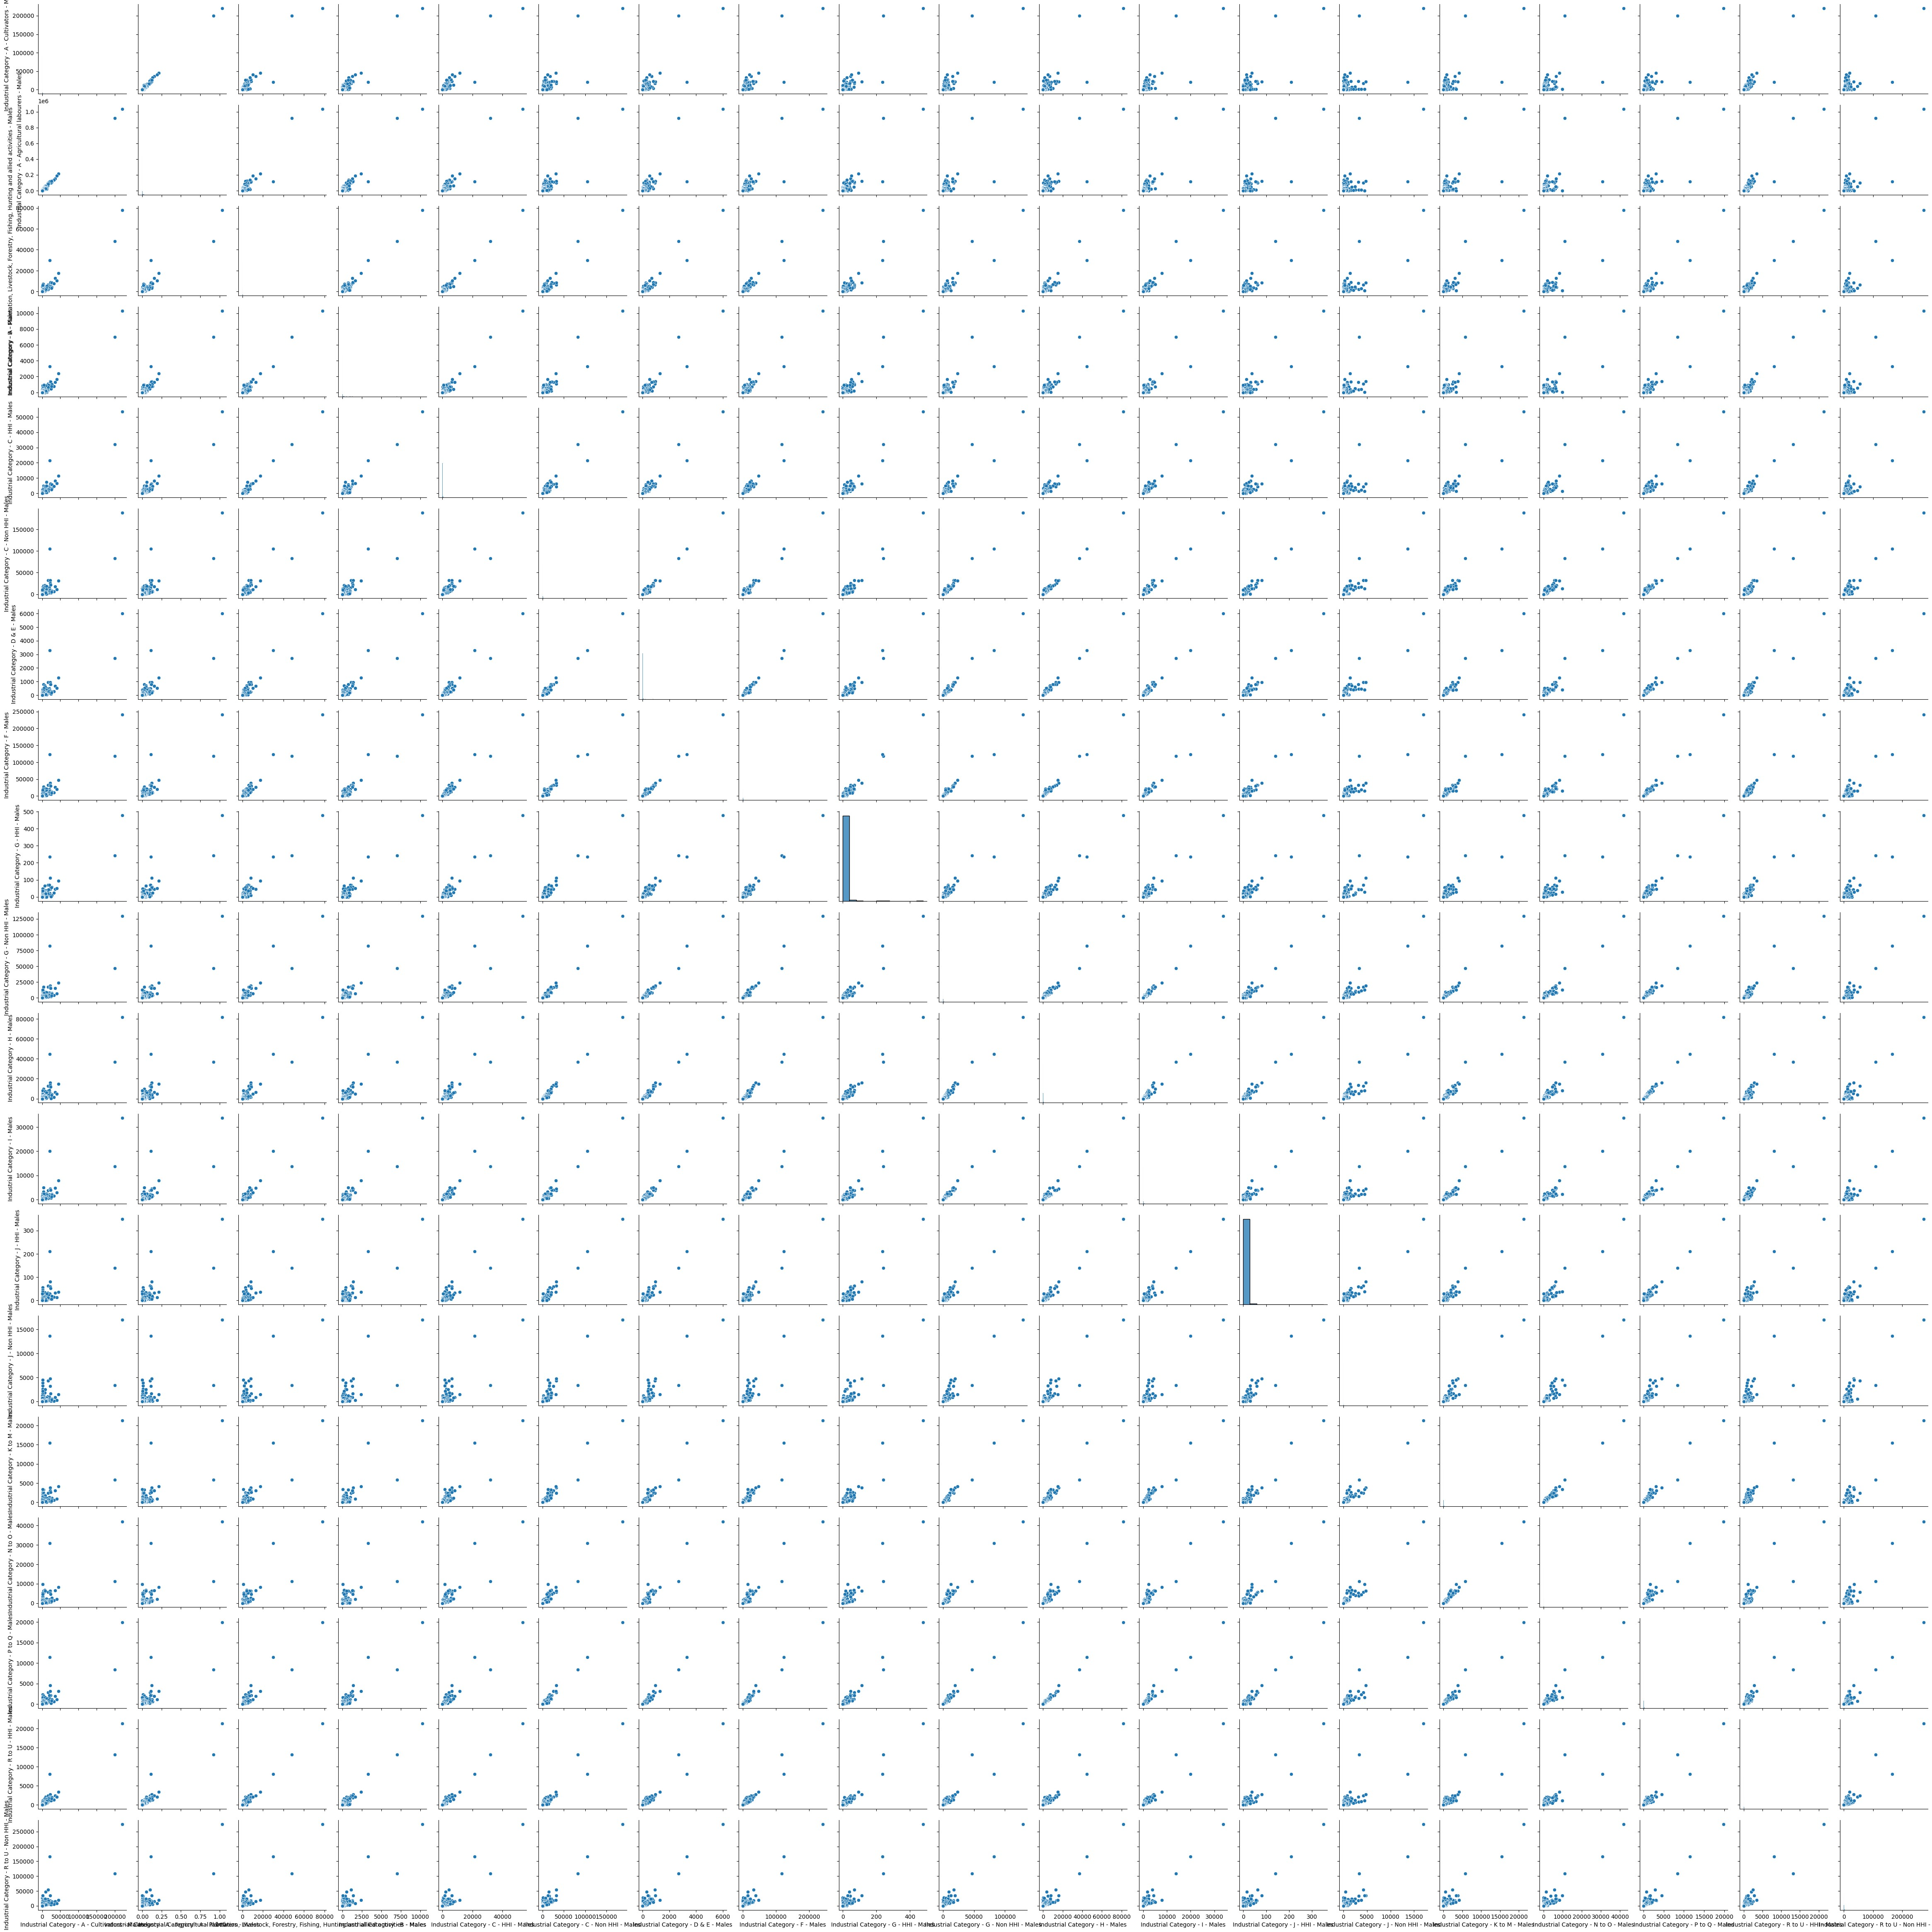

sns

.

pairplot

(

IndustryCategorybyMale

)

1

plt.figure(figsize**=**(30,25)) sns.heatmap(IndustryCategorybyMale.corr(),annot**=True**)

Out[30]: <AxesSubplot: >

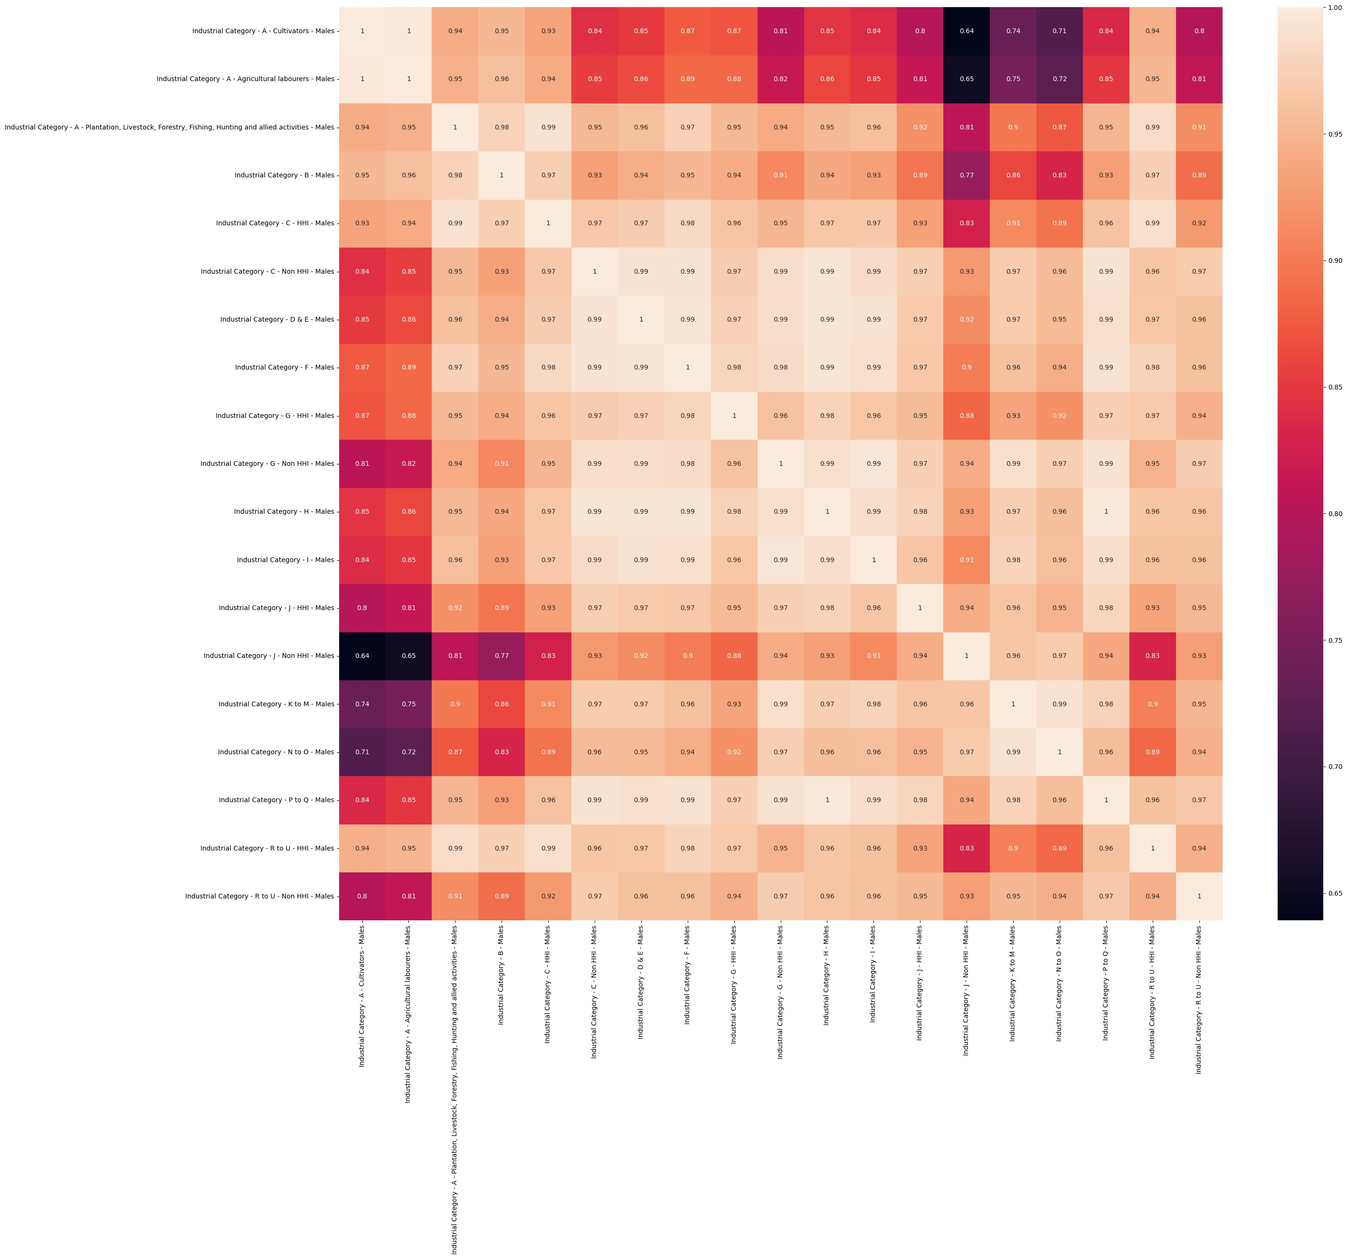

# Analysis by Age group and Industrial category by Females

In [31]: 1 IndustryCategorybyFemale **=** dataset[['Industrial Category - A - Cultiva 2 'Industrial Category - A - Agricultu

1. 'Industrial Category - A - Plantatio
2. 'Industrial Category - B - Females',
3. 'Industrial Category - C - HHI - Fem
4. 'Industrial Category - C - Non HHI -
5. 'Industrial Category - D & E - Femal
6. 'Industrial Category - F - Females',
7. 'Industrial Category - G - HHI - Fem
8. 'Industrial Category - G - Non HHI -
9. 'Industrial Category - H - Females',
10. 'Industrial Category - I - Females',
11. 'Industrial Category - J - HHI - Fem
12. 'Industrial Category - J - Non HHI -
13. 'Industrial Category - K to M - Fema
14. 'Industrial Category - N to O - Fema
15. 'Industrial Category - P to Q - Fema
16. 'Industrial Category - R to U - HHI
17. 'Industrial Category - R to U - Non

In [32]: 1 IndustryCategorybyFemale.head()

Out[32]:

**Industrial**

**Category A -**

**Industrial**

**Industrial Plantation, Industrial Industrial**

**Category - Industrial Industrial Industrial**

**Category - Livestock, Category Category**

**A - Category Category Category**

**A - Forestry, - C - HHI - C - Non**

**Agricultural - B - - D & E - - F -**

**Cultivators Fishing, - HHI labourers - Females Females Females**

**- Females Hunting Females Females**

**Females and allied activities -**

**Females**

1. 172768 1338262 47047 4689 100715 118064 1134 148656
2. 1771 2177 92 6 115 119 2 88
3. 2586 6965 370 31 602 1392 10 441
4. 8528 50343 1456 145 4615 13868 34 2966
5. 16717 118007 2869 398 9992 18346 101 9364

plt.figure(figsize**=**(100,60)) sns.barplot(IndustryCategorybyFemale)

Out[33]: <AxesSubplot: >

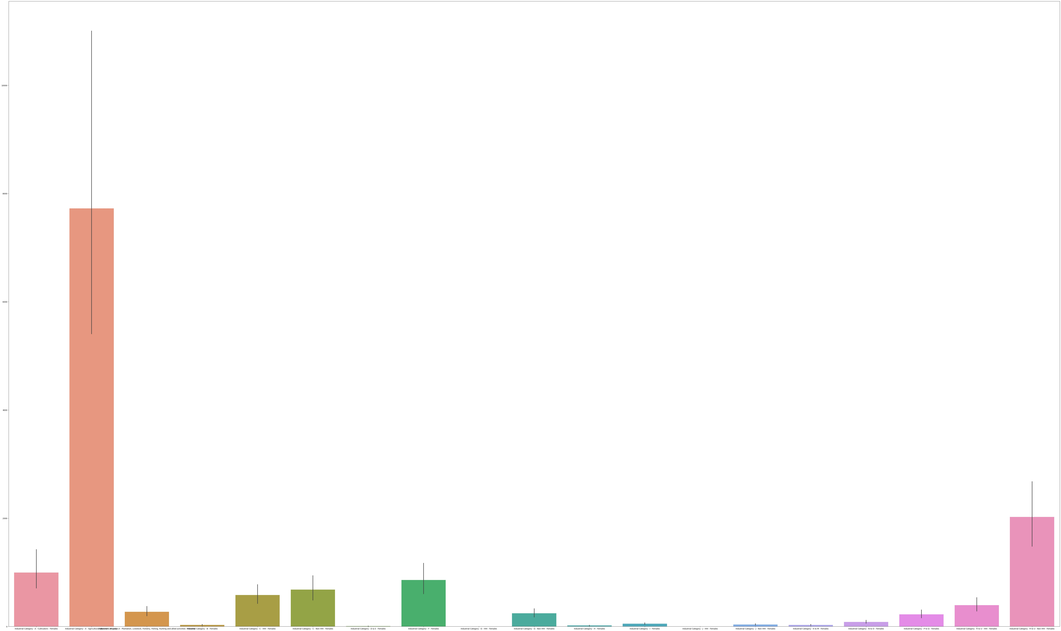

Out[34]:

<

seaborn.axisgrid.PairGrid at 0x1a

9d3058d90>

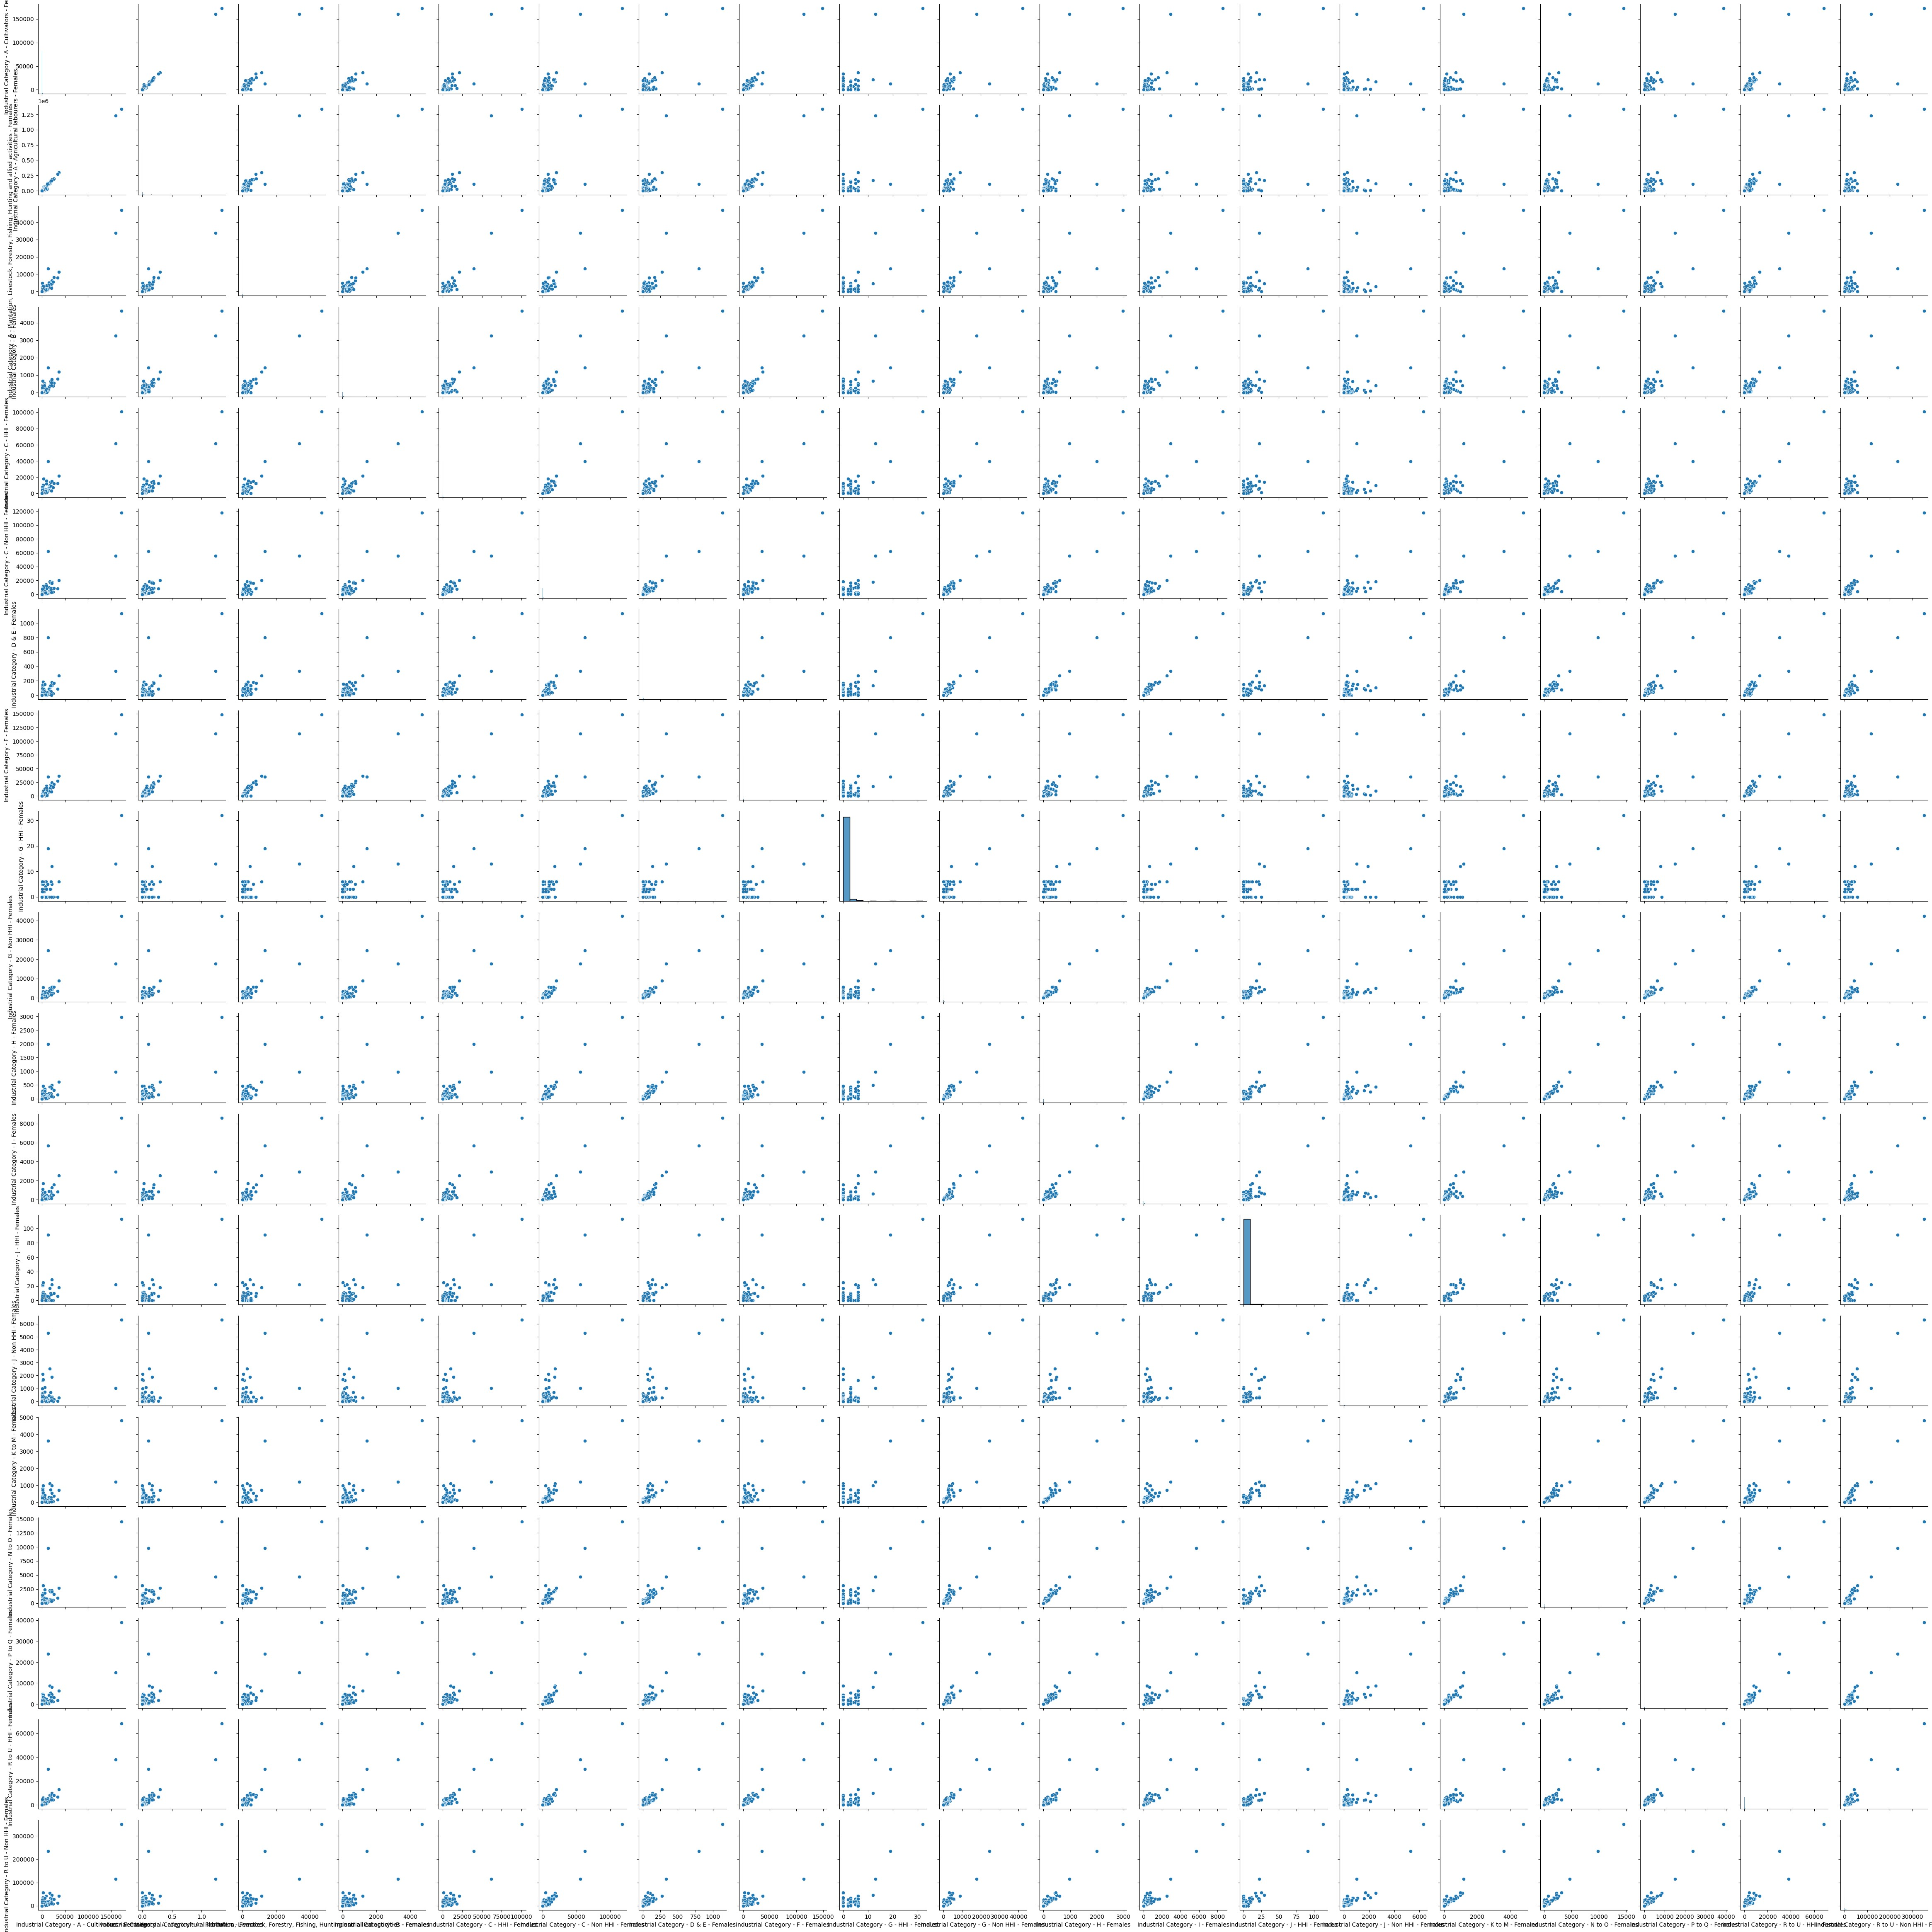

sns

.

pairplot

(

IndustryCategorybyFemale

)

1

plt.figure(figsize**=**(30,25)) sns.heatmap(IndustryCategorybyFemale.corr(),annot**=True**)

Out[35]: <AxesSubplot: >

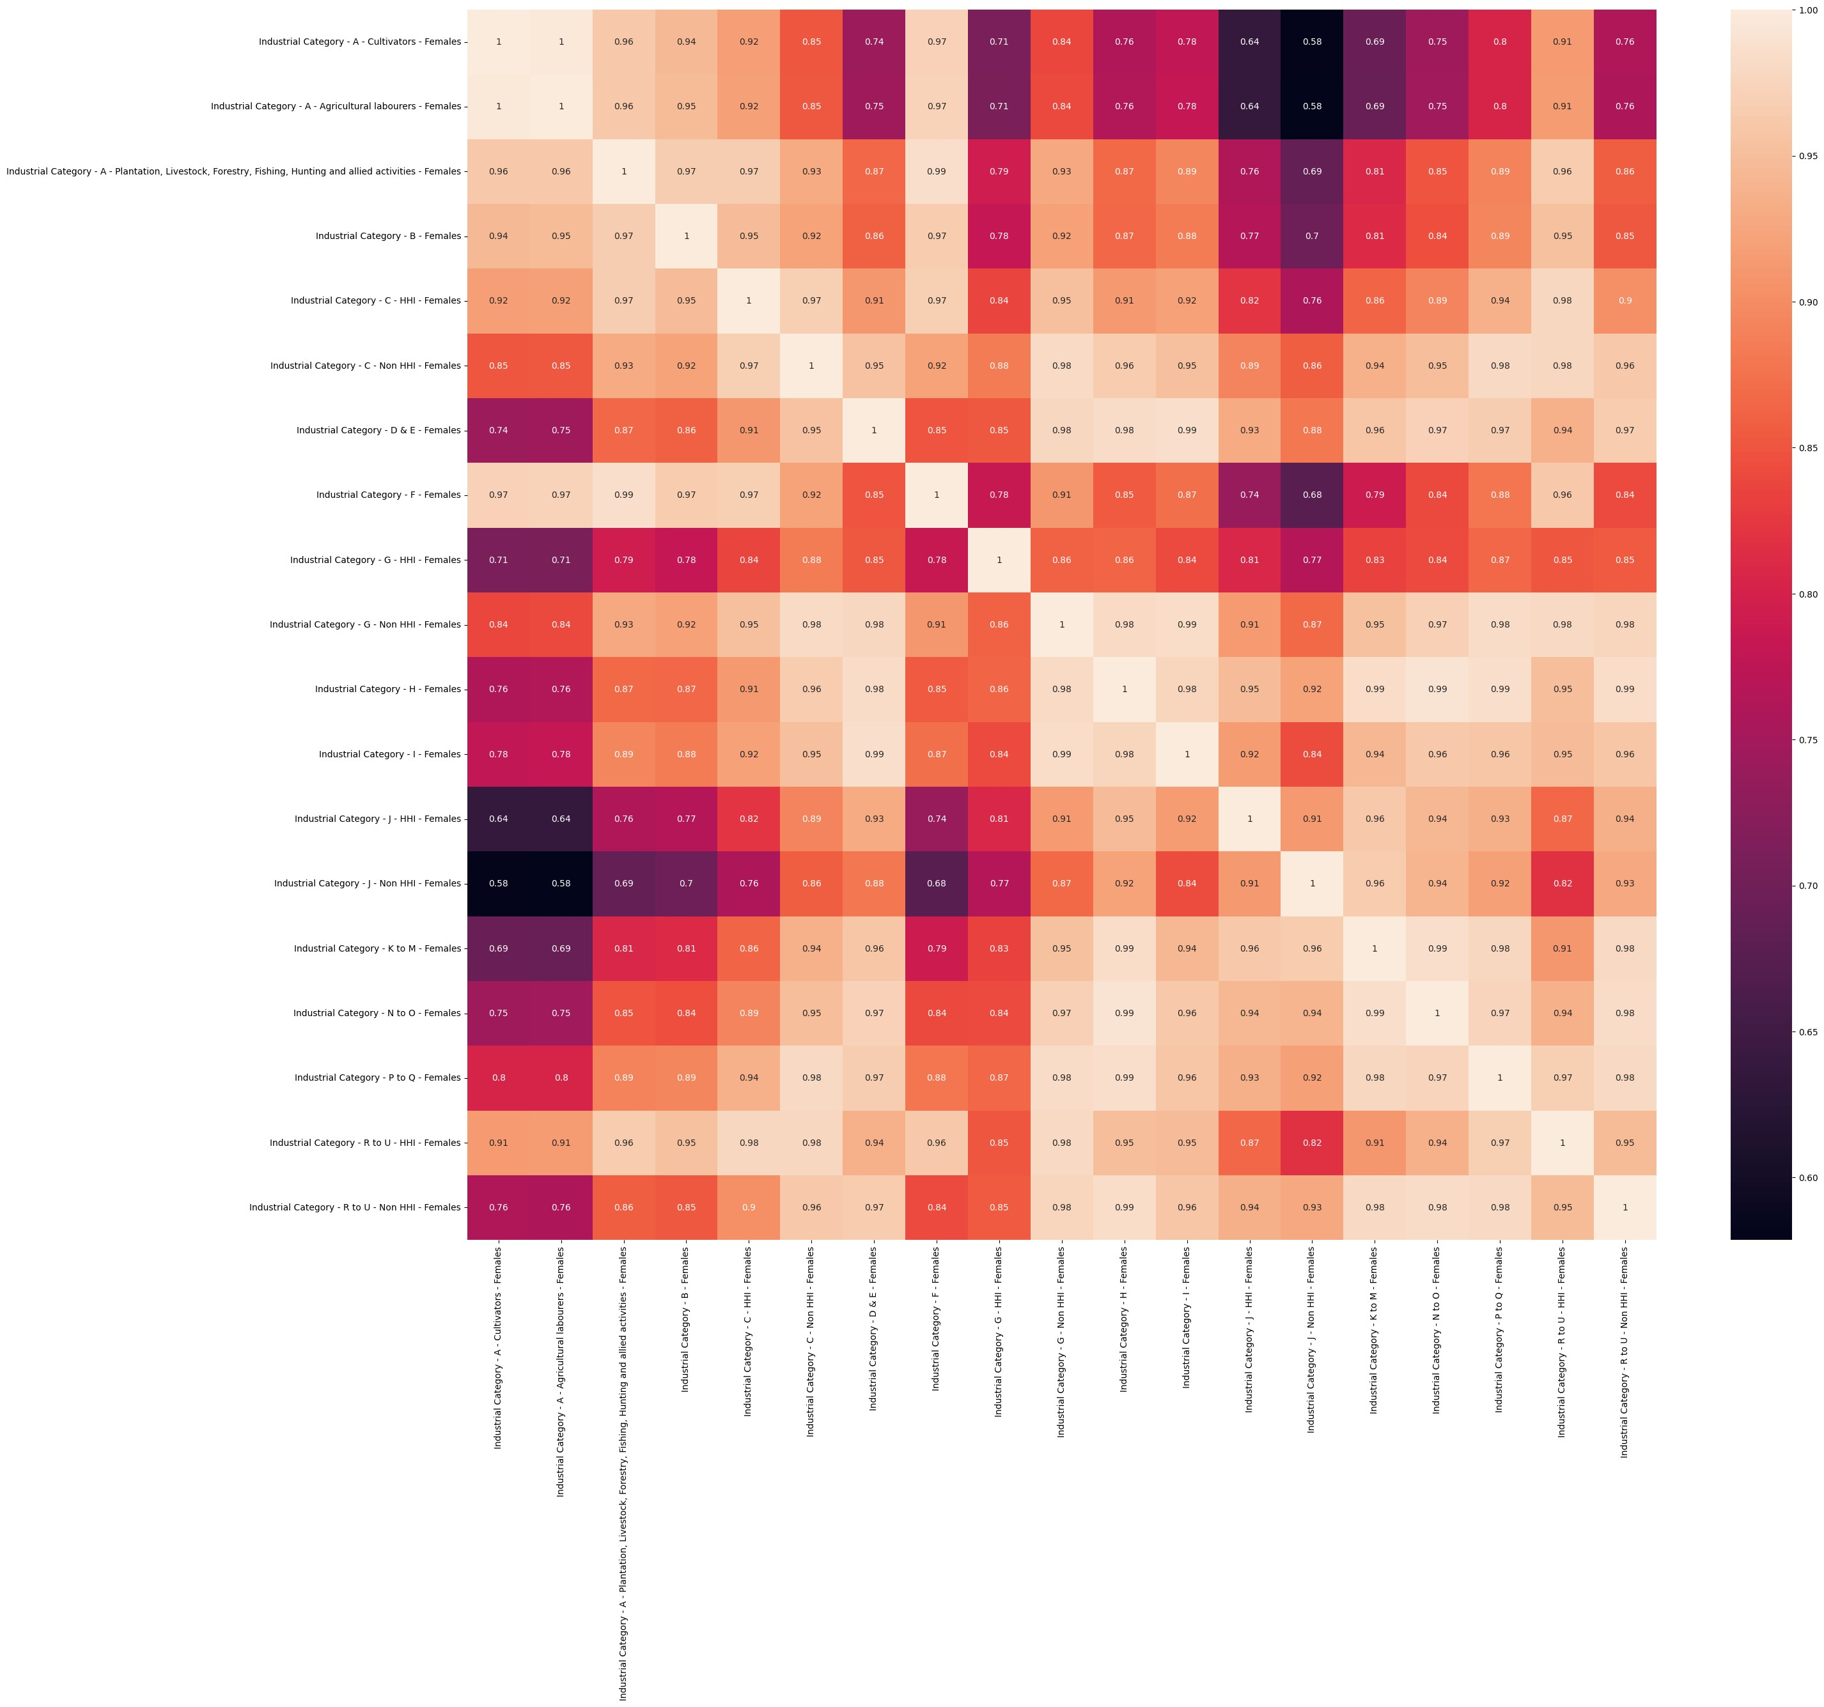

# Visualization of Industrial Category by Age group and Area Name

## Industrial Category A

In [36]: 1 IndustrialCategoryA **=** dataset[['Industrial Category - A - Cultivators

1. 'Industrial Category - A - Cultivators - Males',
2. 'Industrial Category - A - Cultivators - Females',
3. 'Industrial Category - A - Agricultural labourers - Persons', 5 'Industrial Category - A - Agricultural labourers - Males',
4. 'Industrial Category - A - Agricultural labourers - Females',
5. 'Industrial Category - A - Plantation, Livestock, Forestry, Fis
6. 'Industrial Category - A - Plantation, Livestock, Forestry, Fis
7. 'Industrial Category - A - Plantation, Livestock, Forestry, Fis

**Pair Plot**

[37]: plt.figure(figsize**=**(10,10)) sns.pairplot(IndustrialCategoryA)

Out[37]: <seaborn.axisgrid.PairGrid at 0x1aa6ecc2d90>

<Figure size 1000x1000 with 0 Axes>

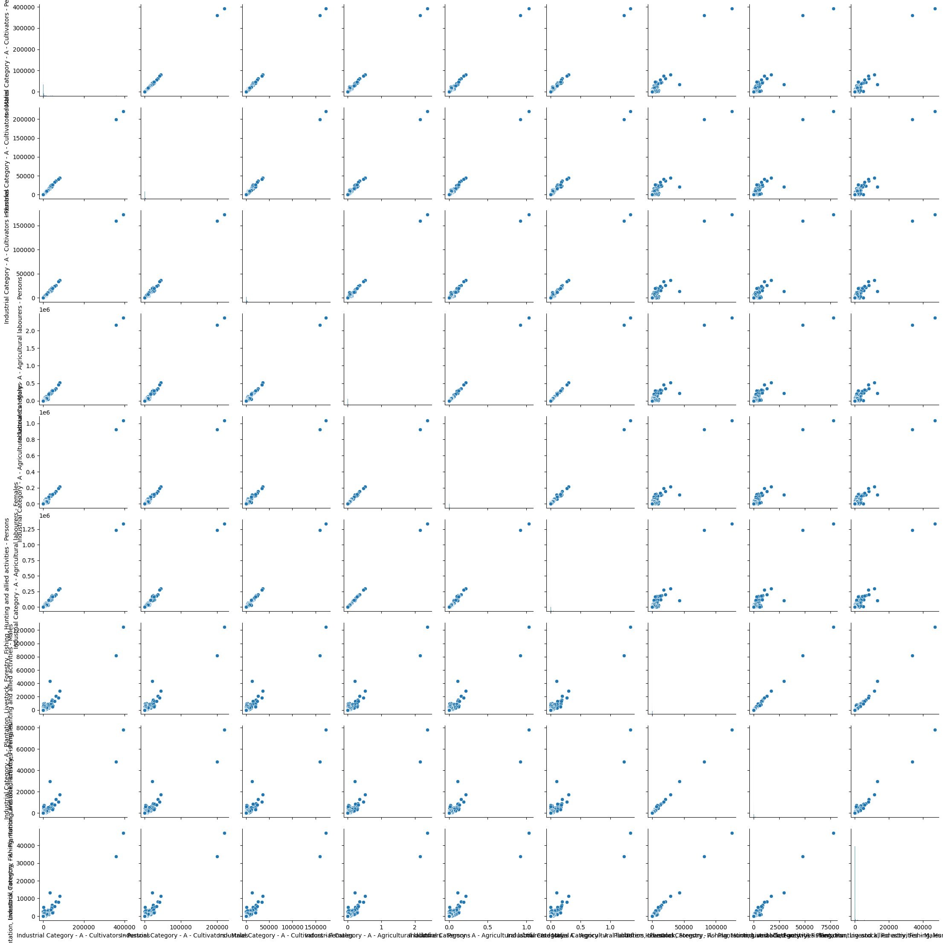

## Industrial Category B

In [38]: 1 IndustrialCategoryB **=** dataset[['Industrial Category - B - Persons', 'I 2 'Industrial Category - B - Females',]]

**Pair Plot**

[39]: sns.pairplot(IndustrialCategoryB) plt.xticks(rotation**=**30)

Out[39]: (array([-2000., 0., 2000., 4000., 6000.]),

[Text(-2000.0, 0, '−2000'), Text(0.0, 0, '0'),

Text(2000.0, 0, '2000'),

Text(4000.0, 0, '4000'),

Text(6000.0, 0, '6000')])

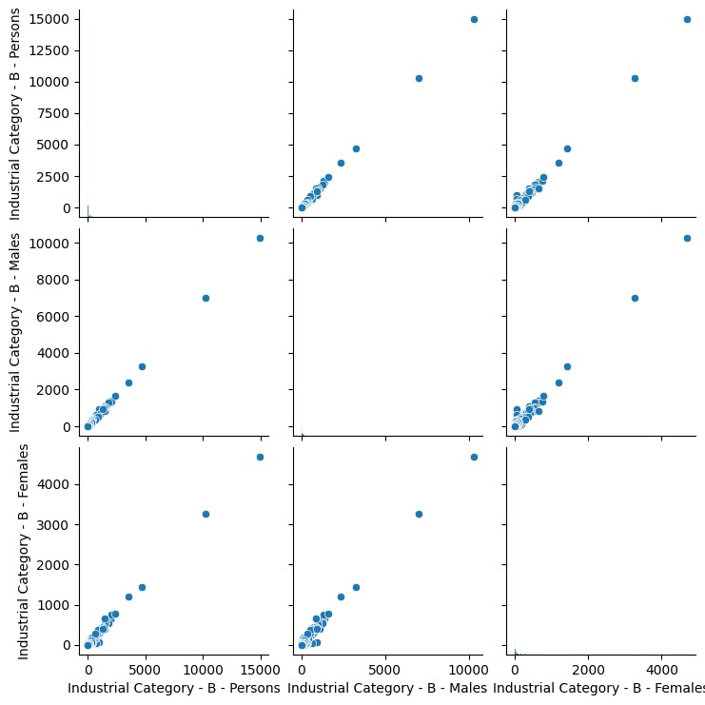

**SUb plot Comparing Age group and Area Name**

[40]: 1 fig, ax **=** plt.subplots(figsize**=**(25,40),nrows**=**3, ncols**=**2)

1. ax[0, 0].plot(IndustrialCategoryB['Industrial Category - B - Persons']
2. ax[0, 1].plot(IndustrialCategoryB['Industrial Category - B - Persons'] 4 ax[1, 0].plot(IndustrialCategoryB['Industrial Category - B - Males'],

5 ax[1, 1].plot(IndustrialCategoryB['Industrial Category - B - Males'], 6 ax[2 ,0].plot(IndustrialCategoryB['Industrial Category - B - Females'] 7 ax[2 ,1].plot(IndustrialCategoryB['Industrial Category - B - Females']

8

1. ax[0,0].set_ylabel("Age group")
2. ax[0,1].set_ylabel("Area Name")
3. ax[0,0].set_title("Person")
4. ax[0,1].set_title("Person")

13

14

1. ax[1,0].set_ylabel("Age group")
2. ax[1,1].set_ylabel("Area Name")
3. ax[1,0].set_title("Males")
4. ax[1,1].set_title("Males")

19

20

1. ax[2,0].set_ylabel("Age group")
2. ax[2,1].set_ylabel("Area Name")
3. ax[2,0].set_title("Females")
4. ax[2,1].set_title("Femalse")

25

26

27

Out[40]: Text(0.5, 1.0, 'Femalse')

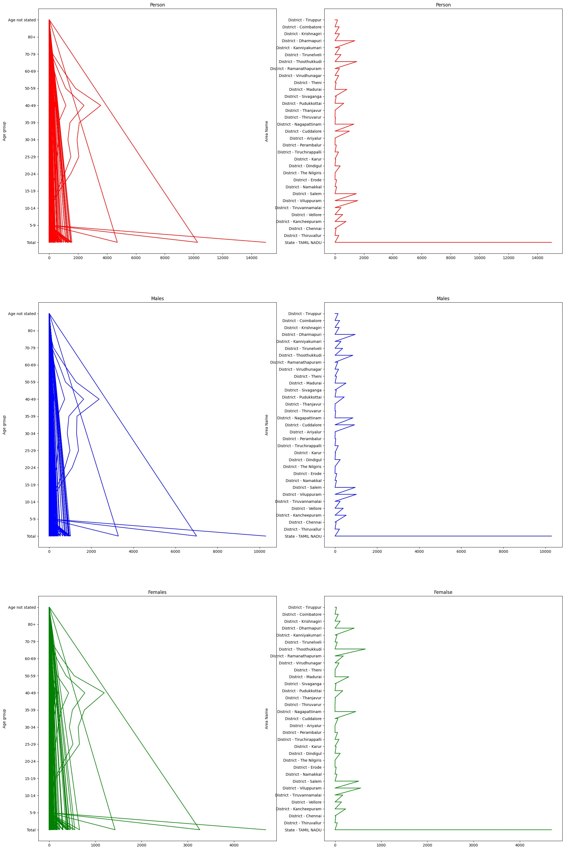

## Industrial Category c

In [41]: 1 IndustrialCategoryC **=** dataset[['Industrial Category - C - HHI - Person

1. 'Industrial Category - C - HHI - Males',
2. 'Industrial Category - C - HHI - Females',
3. 'Industrial Category - C - Non HHI - Persons',
4. 'Industrial Category - C - Non HHI - Males',
5. 'Industrial Category - C - Non HHI - Females']]

**Pair Plot**

In [42]:

sns

.

pairplot

(

IndustrialCategoryC

)

plt

.

xticks

(

rotation

**=**

90

)

1

2

Out[42]: (array([-50000., 0., 50000., 100000., 150000.]),

[Text(-50000.0, 0, '−50000'), Text(0.0, 0, '0'),

Text(50000.0, 0, '50000'),

Text(100000.0, 0, '100000'),

Text(150000.0, 0, '150000')])

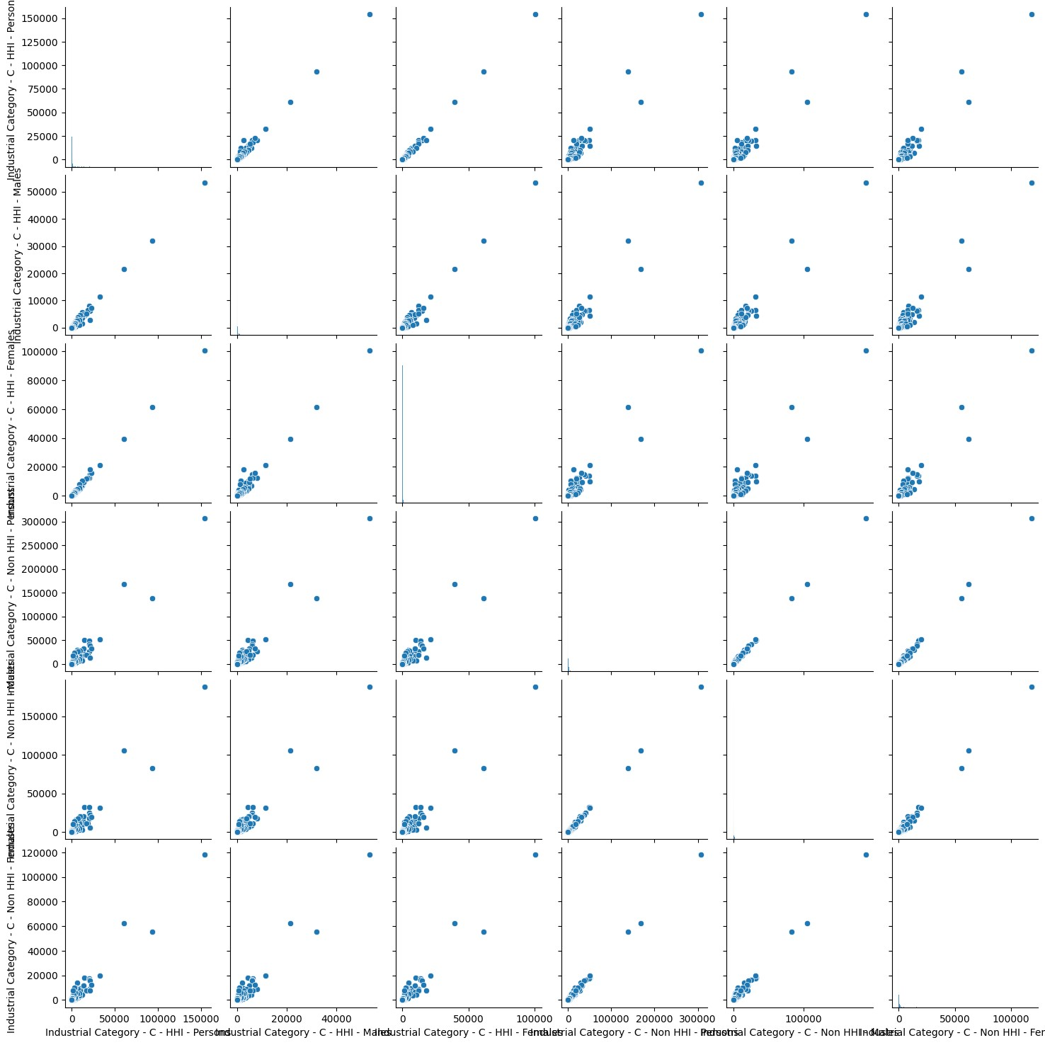

**Sub plot**

In [43]: 1 fig , ax **=**plt.subplots(figsize**=**(30,50),nrows**=**6,ncols**=**2)

### 2 ax[0, 0].plot(dataset['Industrial Category - C - HHI - Persons'], data 3 ax[0, 1].plot(dataset['Industrial Category - C - HHI - Persons'], data

4

1. ax[0,0].set_ylabel("Age group")
2. ax[0,1].set_ylabel("Area Name")
3. ax[0,0].set_title("HHI-Person")
4. ax[0,1].set_title("HHI-Person")

9

1. ax[1, 0].plot(dataset['Industrial Category - C - HHI - Males'], datase
2. ax[1, 1].plot(dataset['Industrial Category - C - HHI - Males'], datase
3. ax[1,0].set_ylabel("Age group")
4. ax[1,1].set_ylabel("Area Name")
5. ax[1,0].set_title("HHI-Males")
6. ax[1,1].set_title("HHI-Males")

16

17

1. ax[2, 0].plot(dataset['Industrial Category - C - HHI - Females'], data
2. ax[2, 1].plot(dataset['Industrial Category - C - HHI - Females'], data
3. ax[2,0].set_ylabel("Age group")
4. ax[2,1].set_ylabel("Area Name")
5. ax[2,0].set_title("HHI-Females")
6. ax[2,1].set_title("HHI-Females")

24

1. ax[3, 0].plot(dataset['Industrial Category - C - Non HHI - Persons'],
2. ax[3, 1].plot(dataset['Industrial Category - C - Non HHI - Persons'],
3. ax[3,0].set_ylabel("Age group")
4. ax[3,1].set_ylabel("Area Name")
5. ax[3,0].set_title("Non HHI-Person")
6. ax[3,1].set_title("Non HHI-Person")

31

1. ax[4, 0].plot(dataset['Industrial Category - C - Non HHI - Males'], da
2. ax[4, 1].plot(dataset['Industrial Category - C - Non HHI - Males'], da
3. ax[4,0].set_ylabel("Age group")
4. ax[4,1].set_ylabel("Area Name")
5. ax[4,0].set_title("Non HHI-Males")
6. ax[4,1].set_title("Non HHI-Males")

38

1. ax[5, 0].plot(dataset['Industrial Category - C - Non HHI - Females'],
2. ax[5, 1].plot(dataset['Industrial Category - C - Non HHI - Females'],
3. ax[5,0].set_ylabel("Age group")
4. ax[5,1].set_ylabel("Area Name")
5. ax[5,0].set_title("Non HHI-Females")
6. ax[5,1].set_title("Non HHI-Females")

Out[43]: Text(0.5, 1.0, 'Non HHI-Females')

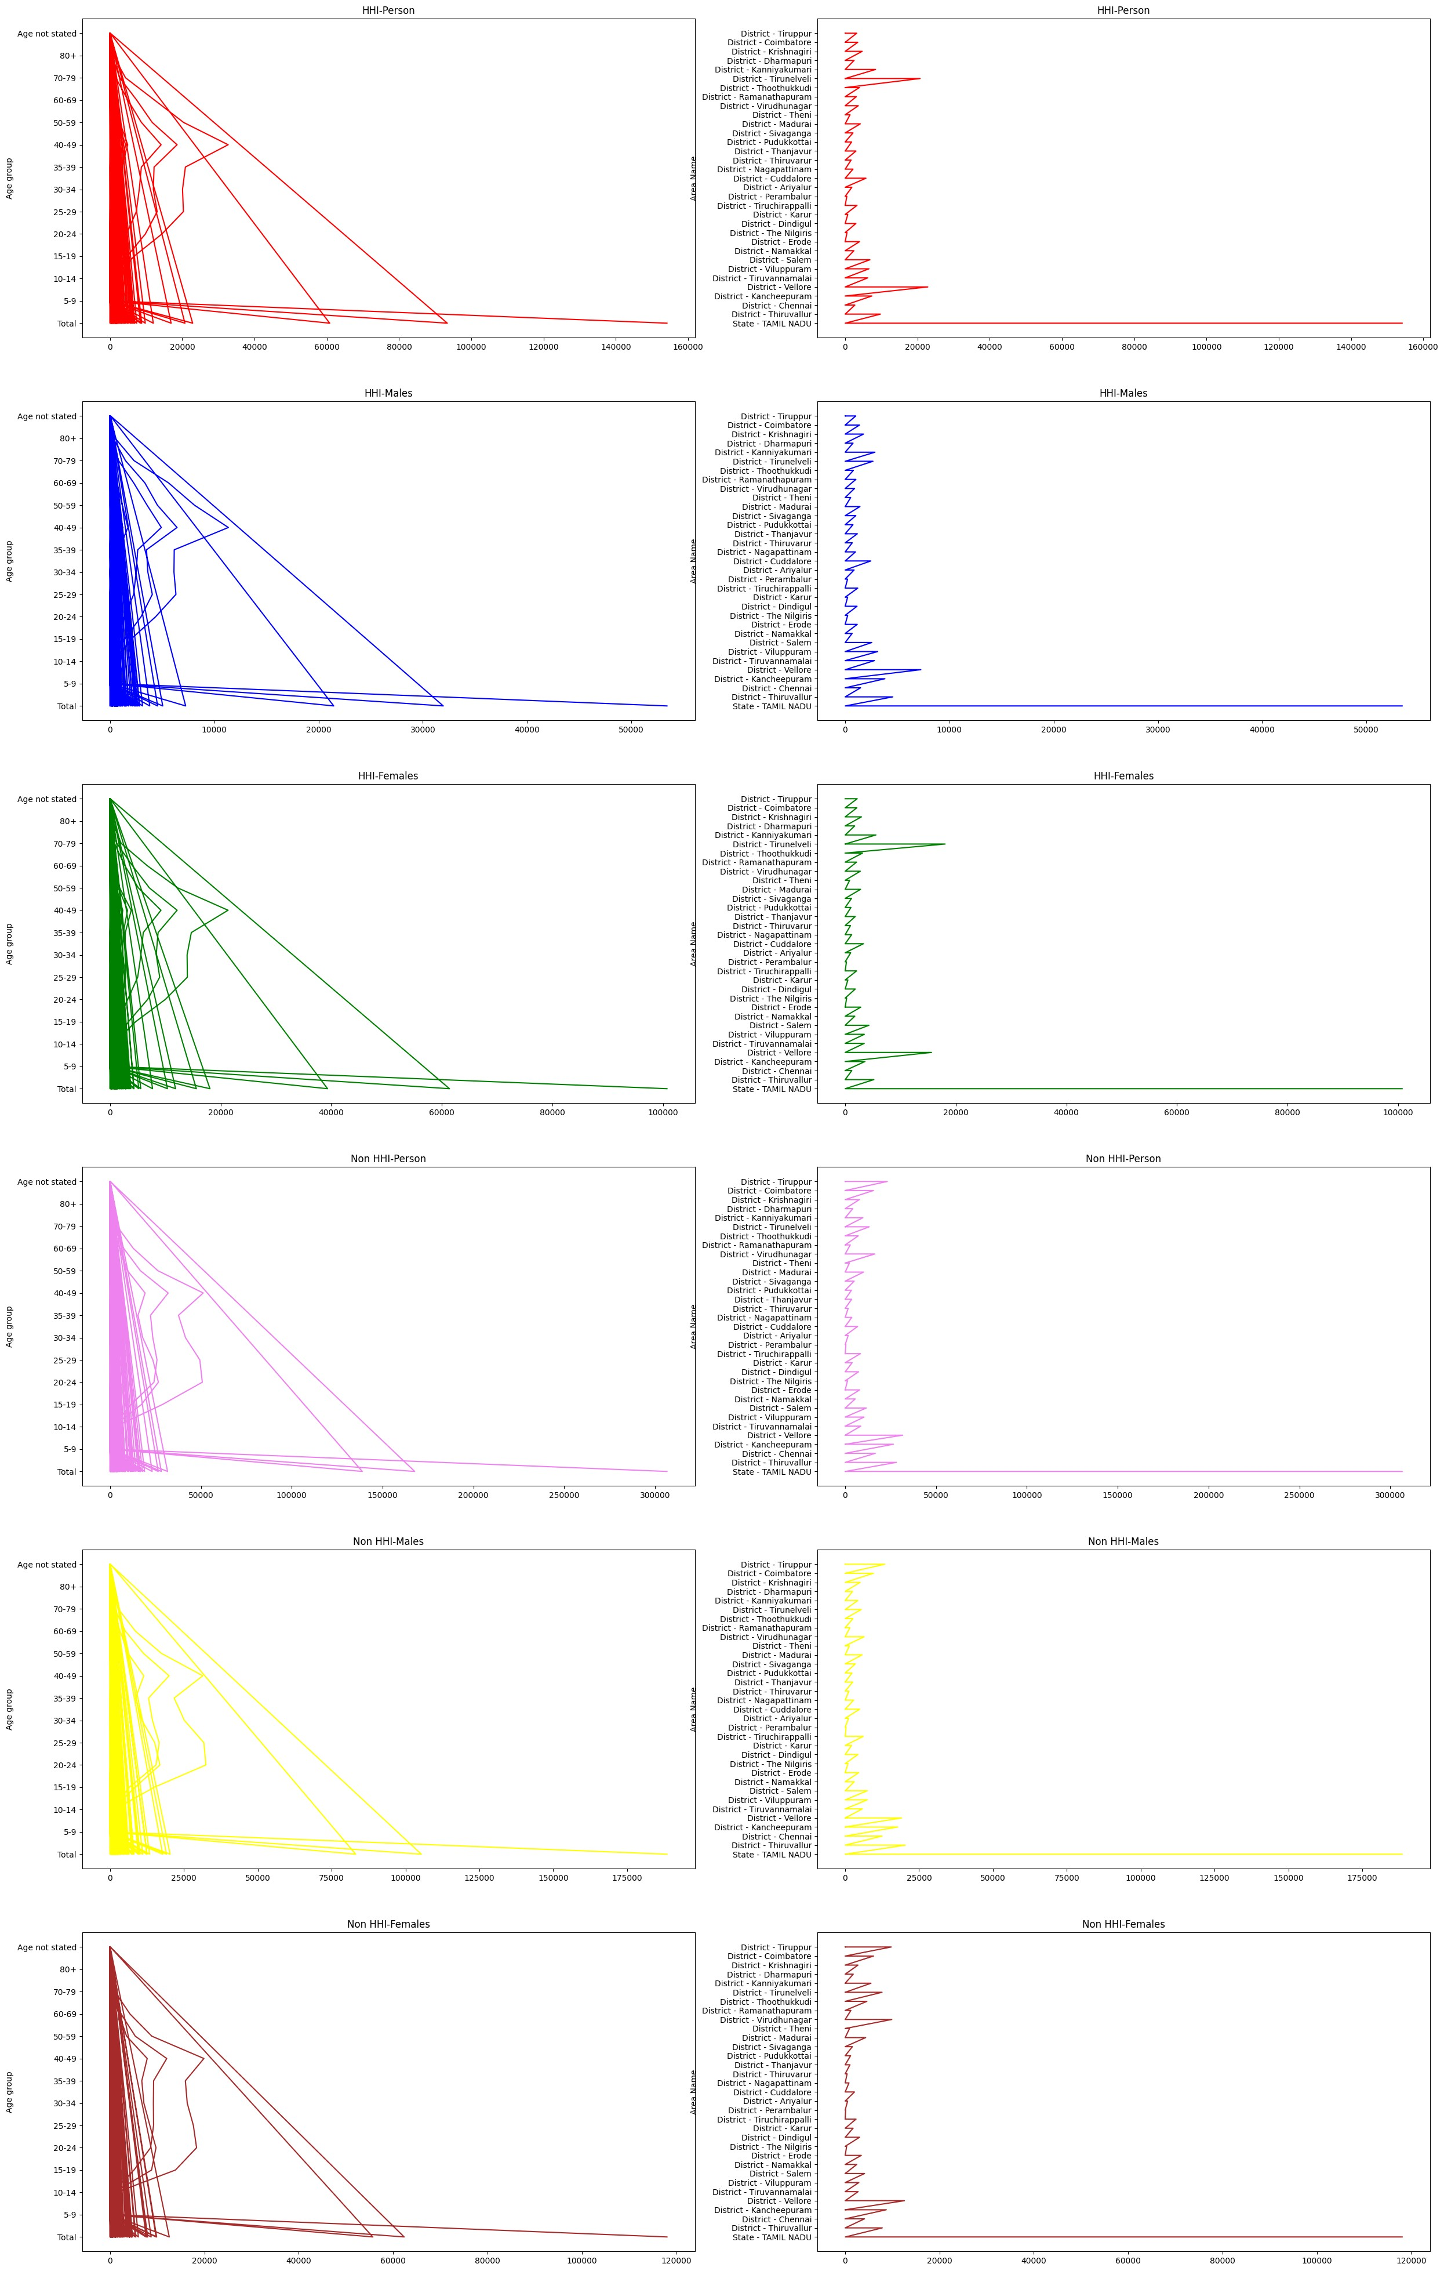

## Calculate the distribution of marginal workers based on age, industrial category, and sex

In [44]:

dataset

.

columns

1

Out[44]: Index(['Table Code', 'State Code', 'District Code', 'Area Name',

'Total/ Rural/ Urban', 'Age group',

'Worked for 3 months or more but less than 6 months - Persons',

'Worked for 3 months or more but less than 6 months - Males',

'Worked for 3 months or more but less than 6 months - Females',

'Worked for less than 3 months - Persons',

'Worked for less than 3 months - Males',

'Worked for less than 3 months - Females',

'Industrial Category - A - Cultivators - Persons',

'Industrial Category - A - Cultivators - Males',

'Industrial Category - A - Cultivators - Females',

'Industrial Category - A - Agricultural labourers - Persons',

'Industrial Category - A - Agricultural labourers - Males',

'Industrial Category - A - Agricultural labourers - Females',

'Industrial Category - A - Plantation, Livestock, Forestry, Fishin g, Hunting and allied activities - Persons',

'Industrial Category - A - Plantation, Livestock, Forestry, Fishin g, Hunting and allied activities - Males',

'Industrial Category - A - Plantation, Livestock, Forestry, Fishin g, Hunting and allied activities - Females',

'Industrial Category - B - Persons', 'Industrial Category - B - Ma les',

'Industrial Category - B - Females',

'Industrial Category - C - HHI - Persons',

'Industrial Category - C - HHI - Males',

'Industrial Category - C - HHI - Females',

'Industrial Category - C - Non HHI - Persons',

'Industrial Category - C - Non HHI - Males',

'Industrial Category - C - Non HHI - Females',

'Industrial Category - D & E - Persons',

'Industrial Category - D & E - Males',

'Industrial Category - D & E - Females',

'Industrial Category - F - Persons', 'Industrial Category - F - Ma les',

'Industrial Category - F - Females',

'Industrial Category - G - HHI - Persons',

'Industrial Category - G - HHI - Males',

'Industrial Category - G - HHI - Females',

'Industrial Category - G - Non HHI - Persons',

'Industrial Category - G - Non HHI - Males',

'Industrial Category - G - Non HHI - Females',

'Industrial Category - H - Persons', 'Industrial Category - H - Ma les',

'Industrial Category - H - Females',

'Industrial Category - I - Persons', 'Industrial Category - I - Ma les',

'Industrial Category - I - Females',

'Industrial Category - J - HHI - Persons',

'Industrial Category - J - HHI - Males',

'Industrial Category - J - HHI - Females',

'Industrial Category - J - Non HHI - Persons',

'Industrial Category - J - Non HHI - Males',

'Industrial Category - J - Non HHI - Females',

'Industrial Category - K to M - Persons',

'Industrial Category - K to M - Males',

'Industrial Category - K to M - Females',

'Industrial Category - N to O - Persons',

'Industrial Category - N to O - Males',

'Industrial Category - N to O - Females',

'Industrial Category - P to Q - Persons',

'Industrial Category - P to Q - Males',

'Industrial Category - P to Q - Females',

'Industrial Category - R to U - HHI - Persons',

'Industrial Category - R to U - HHI - Males',

'Industrial Category - R to U - HHI - Females',

'Industrial Category - R to U - Non HHI - Persons',

'Industrial Category - R to U - Non HHI - Males',

'Industrial Category - R to U - Non HHI - Females'], dtype='object')

## By Persons

In [45]: 1 marginal_worker_criteria_person **=** (dataset['Worked for 3 months or mor 2 dataset['Worked for less than 3 mon

3

1. *# Filter the dataset to only include marginal workers*
2. marginal_workers_person **=** dataset[marginal_worker_criteria_person]

6

1. *# Group the data by age group, industrial category, and sex*
2. grouped **=** marginal_workers_person.groupby(['Age group', 'Total/ Rural/ 9 'Industrial Category - A -
3. 'Industrial Category - A - A
4. 'Industrial Category - A -
5. 'Industrial Category - B -
6. 'Industrial Category - C -
7. 'Industrial Category - F -
8. 'Industrial Category - G -
9. 'Industrial Category - I -
10. 'Industrial Category - J -

### 18 'Industrial Category - N to 19 'Industrial Category - R to

20 ])

21

1. *# Calculate the count of marginal workers in each group*
2. marginal_worker_counts_person **=** grouped.size().reset_index(name**=**'Count

24

1. *# Calculate the total count of marginal workers for all groups*
2. total_marginal_workers_person **=** marginal_worker_counts_person['Count']

27

1. *# Calculate the distribution of marginal workers*
2. marginal_worker_counts_person['Distribution'] **=** (marginal_worker_count 30 **/** total_marginal_work

31

1. *# Print or export the results*
2. marginal_worker_counts_person

Out[45]:

#### Industrial

**Category A -**

#### Industrial

**Industrial Plantation, Industrial Industrial**

**Category - Industrial In**

**Total/ Category - Livestock, Category Category**

**Age A - Category C**

**Rural/ A - Forestry, - C - HHI - C - Non**

**group Agricultural - B - -**

**Urban Cultivators Fishing, - HHI labourers - Persons P**

**- Persons Hunting Persons Persons**

**Persons and allied activities -**

#### Persons

|  |  |  |  |  |  |  |  |  |
| --- | --- | --- | --- | --- | --- | --- | --- | --- |
| **0** | 10-14 | Rural | 11 | 147 | 8 | 0 | 0 | 14 |
| **1** | 10-14 | Rural | 19 | 13 | 2 | 0 | 6 | 8 |
| **2** | 10-14 | Rural | 31 | 31 | 8 | 0 | 8 | 6 |
| **3** | 10-14 | Rural | 45 | 110 | 6 | 0 | 6 | 18 |
| **4** | 10-14 | Rural | 51 | 147 | 10 | 0 | 12 | 42 |
| **...** | ... | ... | ... | ... | ... | ... | ... | ... |
| **1365** | Total | Urban | 2155 | 9687 | 1923 | 322 | 3143 | 14292 |
| **1366** | Total | Urban | 2175 | 16398 | 6655 | 290 | 6732 | 8314 |
| **1367** | Total | Urban | 2253 | 6465 | 2193 | 94 | 4837 | 16719 |
| **1368** | Total | Urban | 4244 | 3423 | 1129 | 71 | 2675 | 16593 |
| **1369** | Total | Urban | 33799 | 217288 | 43198 | 4713 | 60789 | 167693 |

1370 rows × 23 columns

In

[46]:

Out[46]:

Text(0, 0.5, 'Distribution')

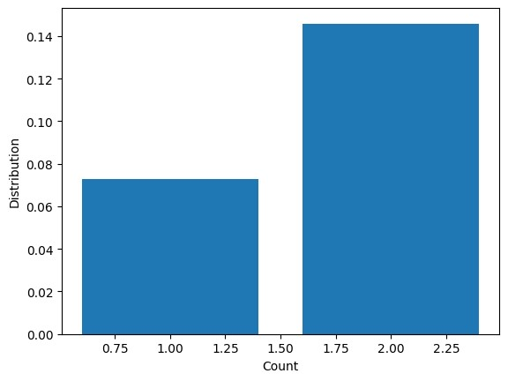

plt

.

bar

(

marginal_worker_counts_person

[

'Count'

]

,

marginal_worker_counts_

plt

.

xlabel

(

'Count'

)

plt

.

ylabel

(

"Distribution"

)

1

2

3

## By Males

In [47]: 1 marginal_worker_criteria_Males **=** (dataset['Worked for 3 months or more 2 dataset['Worked for less than 3 mont

3

1. *# Filter the dataset to only include marginal workers*
2. marginal_workers_Males **=** dataset[marginal_worker_criteria_Males]

6

1. *# Group the data by age group, industrial category, and sex*
2. grouped **=** marginal_workers_Males.groupby(['Age group', 'Total/ Rural/

9

1. *# Calculate the count of marginal workers in each group*
2. marginal_worker_counts_Males **=** grouped.size().reset_index(name**=**'Count'

12

1. *# Calculate the total count of marginal workers for all groups*
2. total_marginal_workers_Males **=** marginal_worker_counts_Males['Count'].s

15

1. *# Calculate the distribution of marginal workers*
2. marginal_worker_counts_Males['Distribution'] **=** (marginal_worker_counts_

18

19 *# Print or export the results* 20 marginal_worker_counts_Males

Out[47]:

### **Industrial**

**Category A -**

### **Industrial**

**Industrial Plantation, Industrial Category - Industrial Industrial In Total/ Category - Livestock, Category**

**Age A - Category Category C**

**Rural/ A - Forestry, - C - Non**

**group Agricultural - B - - C - HHI -**

**Urban Cultivators Fishing, HHI labourers - Males - Males**

**- Males Hunting Males**

**Males and allied activities -**

### **Males**

|  |  |  |  |  |  |  |  |  |
| --- | --- | --- | --- | --- | --- | --- | --- | --- |
| **0** | 10-14 | Rural | 7 | 4 | 2 | 0 | 0 | 6 |
| **1** | 10-14 | Rural | 8 | 76 | 2 | 0 | 0 | 2 |
| **2** | 10-14 | Rural | 9 | 18 | 2 | 0 | 6 | 6 |
| **3** | 10-14 | Rural | 22 | 49 | 0 | 0 | 0 | 14 |
| **4** | 10-14 | Rural | 25 | 79 | 0 | 0 | 6 | 0 |
| **...** | ... | ... | ... | ... | ... | ... | ... | ... |
| **1362** | Total | Urban | 1348 | 5288 | 1492 | 207 | 1803 | 9763 |
| **1363** | Total | Urban | 1394 | 3529 | 1605 | 84 | 2403 | 12527 |
| **1364** | Total | Urban | 1723 | 13310 | 5953 | 258 | 2398 | 3551 |
| **1365** | Total | Urban | 2188 | 1830 | 1010 | 55 | 1477 | 12498 |
| **1366** | Total | Urban | 20874 | 112532 | 29883 | 3286 | 21456 | 105343 |

1367 rows × 23 columns

In

[48]:

Out[48]:

<

AxesSubplot: xlabel='Distribution', ylabel='Count'

>

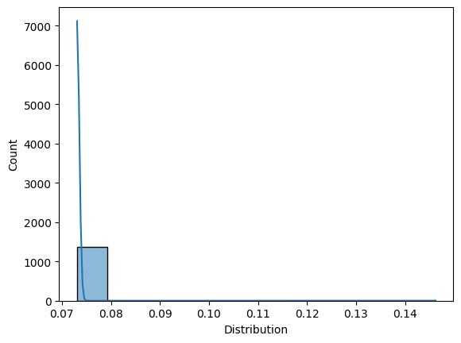

sns

.

histplot

(

marginal_worker_counts_Males

[

'Distribution'

]

,

kde

**=**

**True**

)

1

## By Females

In [49]: 1 marginal_worker_criteria_Females **=** (dataset['Worked for 3 months or mo 2 dataset['Worked for less than 3 mont

3

1. *# Filter the dataset to only include marginal workers*
2. marginal_workers_Females **=** dataset[marginal_worker_criteria_Females]

6

1. *# Group the data by age group, industrial category, and sex*
2. grouped **=** marginal_workers_Females.groupby(['Age group', 'Total/ Rural
3. 'Industrial Category - A -
4. 'Industrial Category - A -
5. 'Industrial Category - B -
6. 'Industrial Category - C -
7. 'Industrial Category - G -
8. 'Industrial Category - G -
9. 'Industrial Category - I -
10. 'Industrial Category - J -

### 17 'Industrial Category - N t 18 'Industrial Category - R t

19

1. *# Calculate the count of marginal workers in each group*
2. marginal_worker_counts_Females **=** grouped.size().reset_index(name**=**'Coun

22

1. *# Calculate the total count of marginal workers for all groups*
2. total_marginal_workers_Females **=** marginal_worker_counts_Females['Count

25

1. *# Calculate the distribution of marginal workers*
2. marginal_worker_counts_Females['Distribution'] **=** (marginal_worker_coun

28

1. *# Print or export the results*
2. marginal_worker_counts_Females

Out[49]:

#### Industrial

**Category A -**

#### Industrial

**Industrial Plantation, Industrial Industrial**

**Category - Industrial In**

**Total/ Category - Livestock, Category Category**

**Age A - Category C**

**Rural/ A - Forestry, - C - HHI - C - Non**

**group Agricultural - B - -**

**Urban Cultivators Fishing, - HHI labourers - Females F**

**- Females Hunting Females Females**

**Females and allied activities -**

#### Females

|  |  |  |  |  |  |  |  |  |
| --- | --- | --- | --- | --- | --- | --- | --- | --- |
| **0** | 10-14 | Rural | 3 | 71 | 6 | 0 | 0 | 12 |
| **1** | 10-14 | Rural | 12 | 9 | 0 | 0 | 6 | 2 |
| **2** | 10-14 | Rural | 22 | 13 | 6 | 0 | 2 | 0 |
| **3** | 10-14 | Rural | 23 | 61 | 6 | 0 | 6 | 4 |
| **4** | 10-14 | Rural | 26 | 68 | 10 | 0 | 6 | 42 |
| **...** | ... | ... | ... | ... | ... | ... | ... | ... |
| **1361** | Total | Urban | 807 | 4399 | 431 | 115 | 1340 | 4529 |
| **1362** | Total | Urban | 812 | 4888 | 1478 | 29 | 1213 | 4097 |
| **1363** | Total | Urban | 859 | 2936 | 588 | 10 | 2434 | 4192 |
| **1364** | Total | Urban | 2056 | 1593 | 119 | 16 | 1198 | 4095 |
| **1365** | Total | Urban | 12925 | 104756 | 13315 | 1427 | 39333 | 62350 |

1366 rows × 23 columns

[50]:

Out[50]:

Text(0, 0.5, 'Distribution')

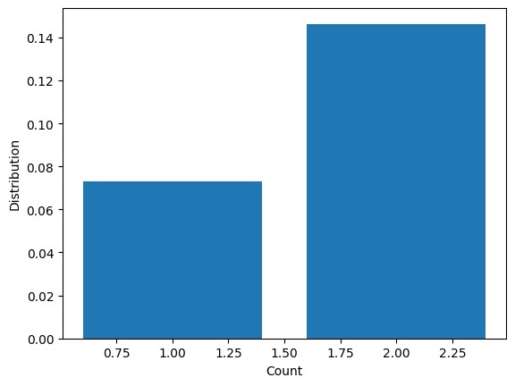

plt

.

bar

(

marginal_worker_counts_Females

[

'Count'

]

,

marginal_worker_counts_

plt

.

xlabel

(

"Count"

)

plt

.

ylabel

(

"Distribution"

)

1

2

3

## Age distribution

In [51]:

dataset

[

'Age group'

].

value_counts

()

1

Out[51]: Total 99 5-9 99

10-14 99

15-19 99

20-24 99

25-29 99

30-34 99

35-39 99

40-49 99

50-59 99

60-69 99

70-79 99

80+ 99

Age not stated 99

Name: Age group, dtype: int64

[52]:

dataset

[

'Age group'

].

mode

()

1

Out[52]: 0 10-14 1 15-19

1. 20-24
2. 25-29
3. 30-34
4. 35-39
5. 40-49
6. 5-9
7. 50-59
8. 60-69
9. 70-79
10. 80+
11. Age not stated
12. Total

Name: Age group, dtype: object

[53]:

plt

.

hist

(

dataset

[

'Age group'

])

plt

.

xticks

(

rotation

**=**

90

)

1

2

Out[53]: ([0, 1, 2, 3, 4, 5, 6, 7, 8, 9, 10, 11, 12, 13],

[Text(0, 0, 'Total'), Text(1, 0, '5-9'),

Text(2, 0, '10-14'),

Text(3, 0, '15-19'),

Text(4, 0, '20-24'),

Text(5, 0, '25-29'),

Text(6, 0, '30-34'),

Text(7, 0, '35-39'),

Text(8, 0, '40-49'),

Text(9, 0, '50-59'),

Text(10, 0, '60-69'),

Text(11, 0, '70-79'),

Text(12, 0, '80+'),

Text(13, 0, 'Age not stated')])

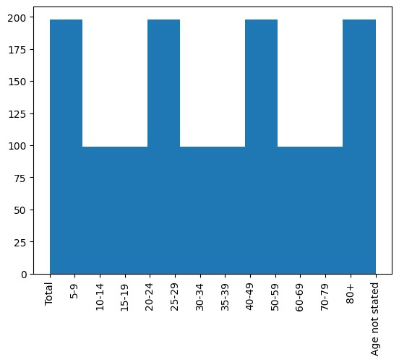

**From the analysis:**

The analysis of demographic characteristics of marginal workers in Tamil Nadu provides valuable insights into their socioeconomic status and living conditions. Here's how the analysis provides these insights:

**1. Age Distribution:**

* By analyzing the age distribution of marginal workers through techniques like histograms or bar charts, the analysis can reveal the dominant age groups among this population. Insights gained from this include whether younger or older individuals are more likely to be engaged in temporary or seasonal employment.
* For example, if the analysis shows that a significant portion of marginal workers falls within the age group of 20-40 years, it suggests that this demographic group is more susceptible to seasonal employment. This insight can guide policies aimed at supporting these age groups during non-employment periods.

**2. Industry Category:**

* Categorizing and visualizing marginal workers by industry category, such as agriculture, manufacturing, construction, and services, offers insights into the diversity of their occupational choices.
* It can help identify which industries employ a substantial number of marginal workers, providing a basis for targeted interventions and policies to improve working conditions in these sectors.

**3. Gender Disparities:**

* Analyzing the gender distribution among marginal workers helps uncover potential gender disparities within this workforce. It highlights whether men and women are equally represented or if there is a significant gender imbalance.
* Gender disparities could indicate unequal access to employment opportunities or variations in working conditions, wages, and benefits. The analysis can be used to address gender-specific challenges faced by marginal workers.

**4. Geographic Distribution:**

* If geospatial data is available and utilized in the analysis, it can reveal the geographic distribution of marginal workers across different regions or districts within Tamil Nadu.
* This insight helps policymakers target specific areas that have a higher concentration of marginal workers, potentially indicating areas with greater economic challenges.

1. **Correlations and Trends:** 
   * Through the analysis, correlations and trends can be identified. For instance, the analysis may reveal that younger marginal workers are more likely to be employed in the agricultural sector while older workers are more common in construction.
   * Such findings can inform strategies to provide skill development or training programs tailored to the needs of specific age groups and industries.
2. **Data-Driven Decision-Making:**

* By providing visual representations and statistical insights, the analysis empowers policymakers, organizations, and researchers to make informed decisions and design interventions to improve the socioeconomic conditions of marginal workers.
* It ensures that resources are allocated effectively and efficiently, addressing the specific needs of different demographic groups within the marginal worker population.

In summary, the analysis of demographic characteristics of marginal workers in Tamil Nadu offers a comprehensive understanding of their age distribution, industry preferences, gender disparities, geographical distribution, and potential correlations. These insights are essential for crafting targeted policies, programs, and initiatives aimed at improving the socioeconomic conditions and livelihoods of this vulnerable workforce.

**Conclusion:**

In conclusion, the analysis of the demographic characteristics of marginal workers in Tamil Nadu has provided valuable insights into this vulnerable population, shedding light on their socioeconomic status and living conditions. By examining their age distribution, industry category preferences, and gender disparities, this analysis has generated actionable findings and implications for policymakers, organizations, and researchers.

The key takeaways from the analysis include:

1. **Age Insights**: The dominant age groups among marginal workers have been identified, offering guidance for designing age-specific interventions to support individuals in their pursuit of seasonal or temporary employment.
2. **Industry Diversity:** The categorization and visualization of marginal workers by industry category have revealed the diversity of their occupational choices. This information can be used to target sectors with a high prevalence of marginal workers for improving working conditions and opportunities.
3. **Gender Disparities:** By analyzing gender distribution, potential gender disparities within the marginal worker population have been exposed. Addressing these disparities can help ensure that both men and women have equal access to employment opportunities and equitable working conditions.
4. **Geographic Concentration:** The geographical distribution of marginal workers across different regions has been highlighted, offering insights into areas that may require specific attention and support to uplift the economic conditions of marginal workers.
5. **Correlations and Trends:** The analysis has unveiled correlations and trends within the data, enabling the development of tailored programs and initiatives to meet the unique needs of different demographic groups and industries.

This comprehensive analysis, conducted through data visualization and statistical techniques, equips stakeholders with the knowledge needed to make informed, evidence-based decisions. It serves as a foundation for the formulation of policies and interventions aimed at enhancing the well-being and livelihoods of marginal workers in Tamil Nadu. As we move forward, the insights gained from this analysis can be used to guide and drive positive change, ensuring that marginal workers are better supported and integrated into the economic and social fabric of the region.